
Final
Public Sector Equality Duty
Equality, Diversity and Inclusion (EDI)
Annual Report 2025 - 26

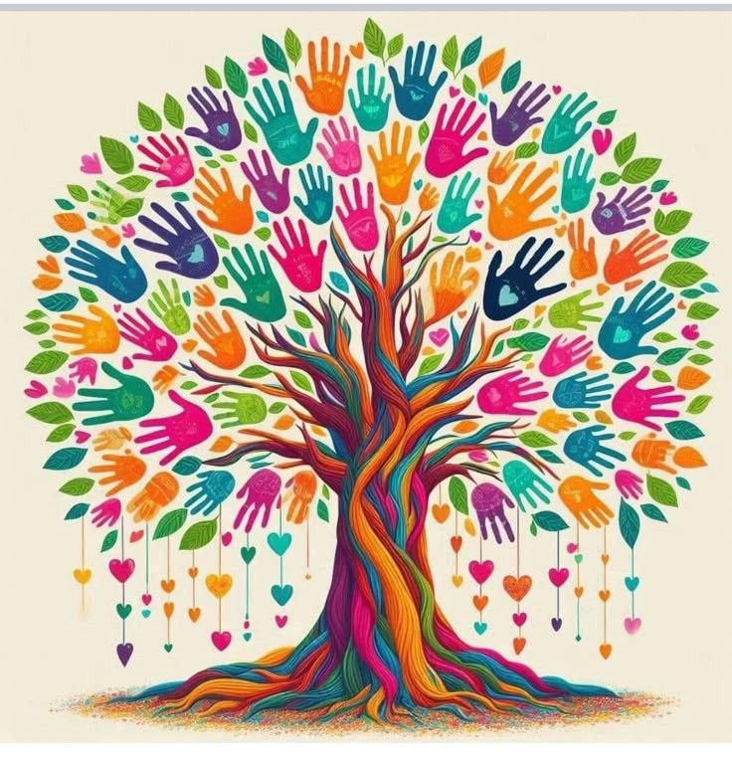

Accessibility Statement
If you would like information in another format, such as another language, Braille, audio or large print, please let us know by calling 0116 295 7532 or emailing LLRICB-LLR.beinvolved@nhs.net to discuss your requirements.

Or you can write to us at:
Freepost Plus RUEE–ZAUY–BXEG
LLR ICB, G30, Pen Lloyd Building,
Leicestershire County Council, Leicester Road
Glenfield, Leicester, LE3 8TB

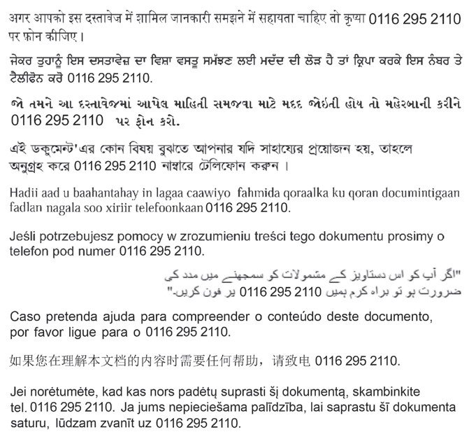

Contents
Accessibility Statement | 2
Welcome to our Equality, Diversity and Inclusion Annual Report  Foreword by Dr Nil Sanganee, Chief Medical Officer | 6  7
NHS Reform - New Ways of Working | 9
Legal Duties for Equality, Diversity and Inclusion | 10
- Equality Act 2010 (including the protected characteristics and intersectionality) | 10
- Other Vulnerable Groups (Inclusion Health Groups) | 11
- Public Sector Equality Duty (PSED) 2011 | 11
- Specific Duties Under the PSED | 12
- Showing ‘Due Regard’ to the Public Sector Equality Duty | 12
- Gender Pay Gap | 13
- Human Rights Act 1998 | 13
- Modern Slavery Act 2015 | 14
- Health and Social Care Act 2022 | 15
- The Care Act 2014 | 15
- Social Value Act 2012 (also referred to as the Public Services Act) | 16
- The Armed Forces Act 2021 (AFC) | 16
- The NHS Constitution | 18
Meeting our Statutory Duties, NHS Mandated Equality Standards and other Equality-related Initiatives | 18
- Adoption of Inclusive Decision-Making Framework (IDMF) | 18
Equality Impact Assessment/Analysis (EIA) incorporating the Inclusive Decision-Making Framework (IDMF) | 22
- Analysis of EIAs undertaken from 1st April 2025-March 2026 | 23
- Additional EIA/Equality Analysis Training | 26
- Specific and Measurable Equality Objectives 2024-2025/26 | 27
- Equality Delivery System (EDS) | 34
- Website Accessibility Standard | 35
- Accessible Information Standard (AIS) 2016 | 35
- Provider Compliance Audit 2025-2026 | 36
Our Workforce (including other relevant statutory & mandated duties) | 37
- People Plan | 37
- Our NHS People Promise | 38
- The NHS Long Term Workforce Plan | 40
- NHS Equality, Diversity and Inclusion Improvement Plan | 41
- Workforce Profile | 42
- Workforce Race Equality Standard (WRES) | 53
- Workforce Disability Equality Standard (WDES) | 54
- Gender Pay Gap Reporting | 54
- Training and Development Opportunities | 55
- Looking after our workforce Health & Wellbeing Including Employee Assistance Programme: Employee Benefits new schemes started in June 2024, Family Financial Wellbeing, Family Friendly Policies and Practices, LLR Leadership Conference: Leading with Care During Turbulent Times, Menopause, Coffee and Chat, Mental Health First Aiders, NHS LLR Talking Therapies – Vita Health Group, The Joy app, National Pulse Survey and National Staff Survey, People Information Board, Continuous Quality Improvement Signposting Board. | 55
- Looking after our Workforce (policies) including the new Zero Tolerance Statement | 60
- Looking after our Workforce (Staff Networks/Champions) – LLR ICB People Forum, Support for Carers, Freedom to Speak Up Champions, Appraisal Champions Network | 61
- Support for Staff during the Restructure | 62
- Communication with Staff, Partners and Diverse Communities | 63
- Working in Collaboration with LLR/Regional Partners  Including: Reverse Mentoring, Inclusive Decision-  Making Framework, Active Bystander Programme,  Your Voice, Visible Leaders Network, Midland’s  People, Talent and Culture Team, Developing Diverse Leadership Programme (DDL); Leicester, Leicestershire and Rutland Nursing, Midwifery and Allied Health Professionals (AHP) Inclusive Leadership Group; Developing Me; Developing You – Midlands Cultural Change Talent Acceleration Programme, Developing Diverse Senior Leaders Programme, The Looking After our People Workstream, LLR Buddying Framework. | 66
Commissioning and Provider Selection | 80
Health Inequalities | 81
- LLR Health Inequalities Strategic Framework - Better Care For All Integrated Care Strategy | 82
- The LLR Health Inequalities Framework | 82
- Core20PLUS5 Framework Adults | 83
- LLR Population and Deprivation Data IMD 2025. | 83
- Core20PLUS5 Children and Young People | 84
- Five National Key Priorities for Systems and Providers | 85
- Fair Allocation of Resources for GP Practices | 86
- LLR’s Statement on Information on Health Inequalities | 86
- NHSE – Annual Assessment of ICB performance 2024/25. Published 17 December 2025 | 88
Engagement and Insights | 89
- Specialist Engagement and consultation with Communities  - East Midlands Fertility Policy Listening Exercise  - Proposals to improve access to same day health services in Rutland | 89  91  93
- LLR ICB People and Communities Strategy (2022-2024) | 96
- Voluntary, Community and Social Enterprise (VCSE) Alliance | 97
- Insights, Behaviour and Research Hub | 98
Conclusion | 99
Forward Plan- Appendix A | 100

Welcome to our Equality, Diversity and Inclusion Annual Report
NHS Integrated Care Boards (ICBs) are statutory bodies established from 1 July 2022.
This report sets out how we, as an ICB, fulfil our responsibilities arising from the Equality Act 2010 and other NHS mandated requirements. The Equality Act requires all ICBs to publish appropriate information which demonstrates how we are meeting the Public Sector Equality Duty 2011 (PSED, specific duties) and addressing any significant gaps which may adversely impact on local people who are protected by equalities law.
This Annual Report covers the period April 1st 2025, to 31st March 2026.

Foreword by Dr Nil Sanganee, Chief Medical Officer
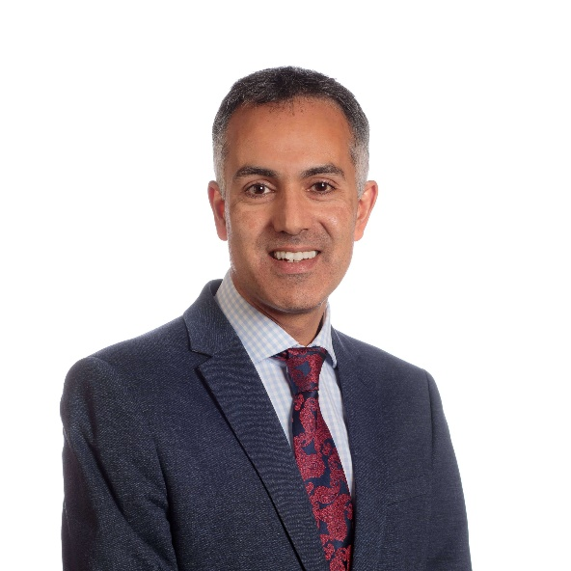

We are pleased to publish our Equality, Diversity and Inclusion (EDI) Annual Report for 2025-6. As an organisation, we are dedicated to developing an organisational culture that promotes inclusion and embraces diversity, ensuring that the focus on EDI is maintained not only within the ICB but as part of the wider Integrated Care System. One of our Strategic Plan pledges is to make Leicester Leicestershire and Rutland (LLR) health and care, a great place to work and volunteer, which includes our commitment to inclusion and diversity.
LLR has some of the most diverse communities and it is important to the ICB and the wider system that the diversity of our population is mirrored in the diversity of our workforce. Across Health and Social care, we employ over 76,000 staff, of which current health workforce data suggests 45% are from a Black, Asian and Minority Ethnic (BME) background, reflecting the diverse race profiles of our population.
Our Integrated Care System aims to deliver a health and care system in LLR that tackles inequalities in health and improves the health, wellbeing and experiences of local people and provides value for money. We can only achieve this through our people and our unwavering commitment to supporting the people that work for health and social care. Our commitment to ensure the work we do has the focus on equality, diversity and inclusion will ensure that the care we deliver to our population will achieve the purpose and aims of the Integrated Care System.

We have a clear purpose:
‘To work together for everyone in LLR to have healthy, fulfilling lives.’

We have four main priorities:
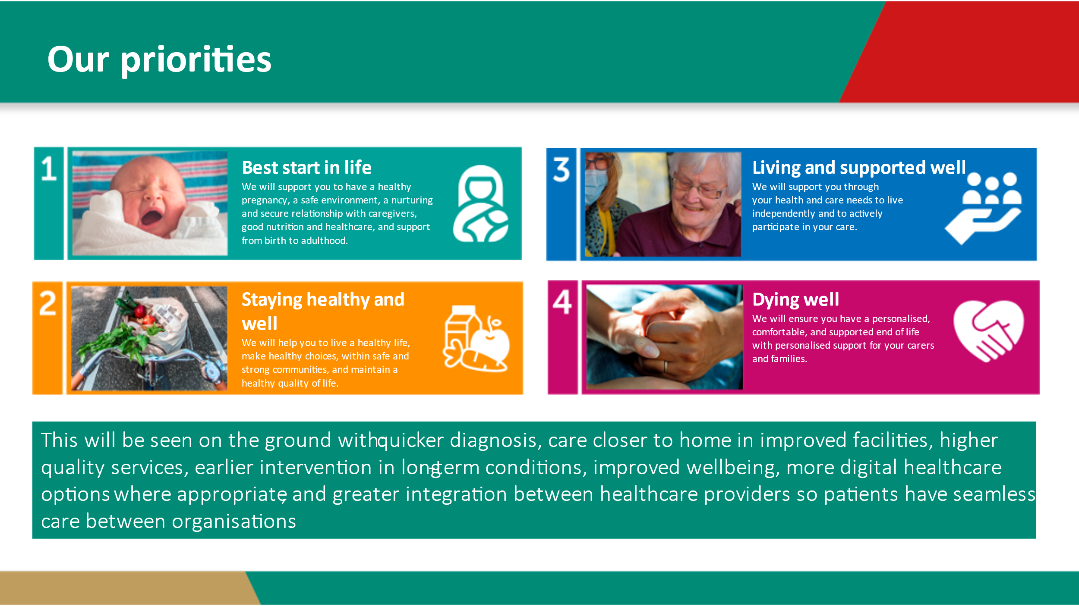

To achieve these priorities, we will ensure that success will be seen on the ground with quicker diagnosis, care closer to home in improved facilities, higher quality services, earlier intervention in long-term conditions, improved wellbeing, more digital healthcare options where appropriate, and greater integration between healthcare providers so patients have seamless care between organisations. For 2026/27 we have an opportunity to further strengthen our approach to health equity and inclusion through the three shifts set out in NHS policy: Analogue to Digital, Cure to Prevention and Hospital to Community.
As we move towards our clustering arrangements with Northamptonshire ICB this may be our final EDI Annual Report as a separate statutory body. As our concluding publication, we are proud to showcase all work we have done over the past year.

Dr Nil Sanganee

Chief Medical Officer

NHS Reform - New Ways of Working
The delivery of the Fit for the Future: 10 Year Health Plan for England will require a leaner and simpler way of working, where every part of the NHS is clear on its purpose, what it is accountable for, and to whom.

On the 2 May 2025, NHS England clarified the role of ICBs by publishing a Model ICB Blueprint to assist ICBs to develop their plans to deliver significant changes on their effectiveness and impact, whilst reducing their operating costs from 2026/27 to be within a funding envelope of £19 (now £19.40) per head of the population.
The Model ICB Blueprint established strategic commissioning as the central purpose for ICBs going forward.
On the 30 May 2025, the ICBs submitted a high-level plan to NHS England to propose forming an NHS Leicestershire, Northamptonshire and Rutland ICB cluster (LNR) to deliver the national requirements from 2025/26, as it was felt that neither organisation were viable on their own given the significant cost reductions.

To respond to the requirements of the Model ICB blueprint, the ICB has been going through a significant change in the function and reduction of their workforce during 2025/26. The restructure will continue into the first few months of the 2026/27 financial year. Unfortunately, this has led to the pausing and discontinuing of some workforce programmes. During this difficult time, the ICB have provided extra support for our workforce. This support can be found on page 62 of this report.

Equality Impact Assessments have been carried out on the implications regarding the ICB workforce.

Legal Duties for Equality, Diversity and Inclusion
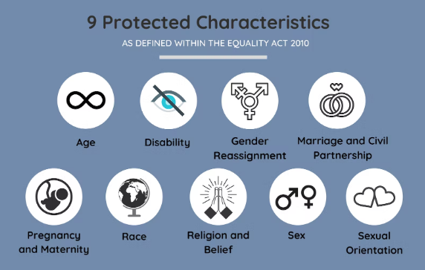
The Equality Act 2010 protects people from unfavourable treatment, making it unlawful to discriminate, harass or victimise an individual due to a reason related to one of the following nine protected characteristics. Click here for more information: Protected Characteristics

Intersectionality: This is the understanding that people are often disadvantaged by multiple factors such as their race, class, gender identity, disability, sexual orientation, religion, and other identity markers.

Intersectionality recognises that identity markers (for example, ‘woman’ and ‘black’ and ‘homeless’) do not exist independently of each other. As such, we recognise the importance of understanding the needs of protected characteristics and inclusion health groups, and how they can intersect with wider determinants of health.

Other Vulnerable Groups (Inclusion Health Groups)
In addition to the nine protected characteristics, we also recognise that there are additional groups that experience health inequalities and face disadvantage in society. These include (but are not limited to):

Carers | Rural and Farming communities
Armed forces community and their families | Asylum seekers and refugees
People experiencing homelessness | People experiencing deprivation
Looked after children and young people | Gypsy, Roma and Traveller communities
People in contact with the justice system | People with poor literacy and/or health literacy
People affected by addiction and/or substance misuse | Sex workers


Public Sector Equality Duty (PSED) 2011
Section 149 of the Equality Act 2010 applies to public sector organisations and bodies delivering public services, and requires the LLR ICB to address the following duties:
- Eliminate unlawful discrimination, harassment, victimisation, and other prohibited conduct.

- Advance equality of opportunity between people who share a protected characteristic and those who do not.

- Foster good relations between people who share a protected characteristic and those that do not.
The Equality Act explains that the second aim involves, in particular, having due regard to the need to:
- Remove or minimise disadvantages suffered by people due to their protected characteristics.

- Take steps to meet the needs of people with certain protected characteristics where these are different from the needs of others.

- Encourage people with certain protected characteristics to participate in public life or in other activities where their participation is disproportionately low.

Specific Duties Under the PSED
LLR ICB have specific duties under the Public Sector Equality Duty (PSED) to:

- Publish information annually to demonstrate their compliance with the equality duties, including information relating to employees who share protected characteristics (for public bodies with 150+ employees), and information relating to people who are affected by the public body’s policies and practices who share protected characteristics.

- Set equality objectives, at least every four years. (These can be found in this Annual Report on page 27).

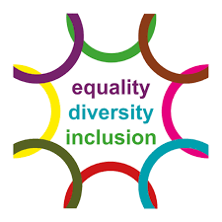
Showing ‘Due Regard’ to the Public Sector Equality Duty

To commission high quality, and inclusive health services, we aim to ensure that protected groups have the same access, experiences, and outcomes as the general population, and where required, to focus on equity of service provision. This may mean that some of our protected groups have enhanced access to services.

We recognise that there are many things that influence this that we may not have complete control over, but we are committed to working with our communities and partners to ensure that our commitment to our equality duty is central to the work that we do and the decisions we make.
One of the ways that we demonstrate ‘due regard’ is though our Equality Impact Assessment (EIA) process. More on this can be found on page 22.

Gender Pay Gap

Since 31 March 2017, all public sector organisations in England employing 250 or more staff have been required to publish annually their gender pay gap information.
The report shows the difference between the average earnings of men and women, expressed relative to men’s earnings. If an organisation reports a gender pay gap, it does not mean women are paid less than men for doing the same job.
The calculations make use of two types of averages, a mean average and a median average. Using these two different types of average is helpful to give a more balanced overview of an employer’s overall gender pay gap.

A copy of the 2025/26 Gender Pay Gap report is available LINK: Gender Pay Gap 2025-6

Human Rights Act 1998
The Human Rights Act 1998 sets out universal standards to ensure that an individual’s basic needs as a human being are recognised and met.
Public authorities have a mandated duty to ensure they have arrangements in place to comply with the Act.
It is unlawful for a healthcare organisation to act in any way that is incompatible with the Act. In practice, this means we must treat individuals with Fairness, Respect, Equality, Dignity and Autonomy known as the FREDA principles. LINK: Human Rights Act

Modern Slavery Act 2015
The Modern Slavery Act 2015 applies to all organisations within the United Kingdom with a turnover of £36 million or above. A key element of the Act is the ‘Transparency in Supply Chains’ provision, which requires businesses above a certain threshold to produce a ‘Slavery and Human Trafficking Statement’ outlining what steps they have taken in their supply chain to ensure slavery and human trafficking is not taking place.
Slavery is a violation of a person’s human rights. It can take the form of trafficking, forced labour, bonded labour, forced or servile marriage, descent-based slavery, and domestic slavery.
The ICB has zero tolerance for modern day slavery and breaches of human rights, so we ensure that this protection is built into the processes and business practices that we, our partners and our providers use.
To view our Modern Slavery Act Statement on our website, please click on to the following link: modern slavery - LLR ICB

The Health and Social Care Act 2022


The ICB has a legal duty under the Health and Social Care Act 2022, to reduce inequalities between people in regard to their ability to access health services, and to reduce inequalities between patients with respect to the outcomes achieved for them by the provision of health services. The Act also places duties on the ICB to promote the NHS Constitution, to enable choice, and to promote patient, carer and public involvement in shaping health services.

To do this effectively, the ICB works with its partner organisations to reduce health inequalities and embeds this requirement into its commissioning strategies and policies. The ICB is also required to demonstrate how it provides culturally sensitive services and ensures all patients can exercise choice and be involved in decision making.
NHS England has a statutory duty under the Health and Social Care Act 2022, to conduct an annual assessment of ICBs. A single oversight framework called the NHS Oversight Framework was introduced in 2022 for this purpose. This includes oversight metrics for reducing health inequalities and racial inequalities.
More information about the NHS System Oversight Framework for can be found at this Link NHS England » NHS Oversight Framework

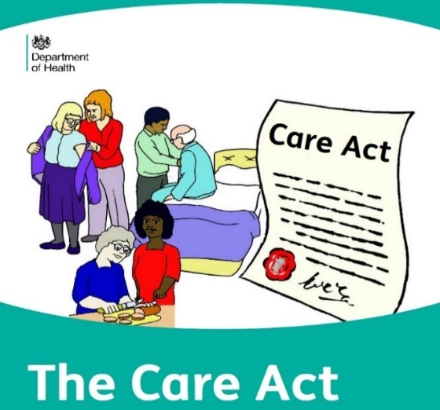
The Care Act (2014)
This sets out carers’ legal rights to assessment and support and relates mostly to adult carers aged 18 and over who are caring for another adult. This is because young carers (aged 17 and under) and adults who care for disabled children can be assessed and supported under children’s law.

Social Value Act 2012 (also referred to as the Public Services Act)
The Social Value Act applies to all public services in the United Kingdom. It requires Public Sector authorities to consider how proposals and procurements might improve the economic, social, and environmental wellbeing of the relevant area, and how, in conducting the process of procurement, it might act with a view to securing that improvement.

The Armed Forces Act 2021 (AFC)


The Armed Forces Act 2021 came into effect in November 2022, to reinforce the Armed Forces Covenant. The duty is a legal obligation on certain public bodies to pay “due regard’ to the principles of the Covenant and requires decisions about the development and delivery of certain services to be made with conscious consideration of the needs of the AFC.

The Armed Forces Covenant Duty is the following legal obligation. When a specified body exercises a relevant function, it must have due regard to:
- the unique obligations of, and sacrifices made by, the Armed Forces,
- the principle that it is desirable to remove disadvantages arising for Service people from membership, or former membership, of the Armed Forces; and,
- the principle that special provision for Service people may be justified by the effects on such people of membership, or former membership, of the Armed Forces.
The obligation in the 2021 Act impacts organisations that are responsible for delivering principally statutory functions in healthcare, education, and housing services.In healthcare, we are supported by specific commissioning guidance issued by NHS England (NHSE), which links to their Forward View for the AFC to guide us in these developments.
By the Armed Forces Community, we are referring to:
- Regular serving personnel.
- Reserve personnel.
- Veterans – Individuals aged 16 plus who have previously served in the UK Armed Forces.
- Families of all – Spouse, Children, Bereaved and carers.



LLR were honoured to be awarded with the prestigious Silver Award in the Ministry of Defence Employer Recognition Scheme, the second highest accolade available to organisations through the Armed Forces Covenant. This recognition reflects our continued commitment to supporting our Armed Forces Community, including veterans, reservists, service leavers, and military families.
LINK: Defence Employer Recognition Scheme - GOV.UK
- The Silver Award is only presented to organisations that are proactive in demonstrating that the Armed Forces Community are not unfairly disadvantaged in recruitment and selection processes, whilst ensuring awareness of positive HR local policies across the current workforce.

- The award not only helps our current workforce, but also our population and prospective employees from the Armed Forces Community know of our commitment, strengthening our voice for the Armed Forces Community in LLR. As one of only two Silver Award winners in Leicestershire, we have a key role in wider promotion of the benefits of engagement of defence partners and local support, across our Health and Care system partnership.

- A special thanks to all our LLR Armed Forces Community stakeholders who have been very supportive and worked in collaboration with the ICB in support of our LLR Armed Forces Community.

The NHS Constitution
The NHS Constitution came into law as part of the Health Act in November 2009 and has recently been updated in January 2021.

It contains seven principles that guide the NHS, as well as a number of pledges for patients and the public.

Several of these, demonstrate the commitment of the NHS to the requirements of the Equality Act 2010 and the Human Rights Act 1998. For example, the first principle requires that the NHS “is available to all, irrespective of gender, race, disability, age, sexual orientation, religion, belief, gender reassignment, pregnancy and maternity or marital or civil partnership status.”

Meeting our Statutory Duties, NHS Mandated Equality Standards and other Equality-related Initiatives

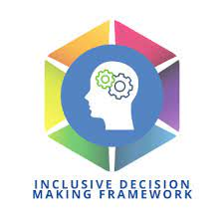
Adoption of Inclusive Decision-

Making Framework (IDMF)
In July 2020, a number of LLR System Equality, Diversity and Inclusion (EDI) priorities were identified by the Leicester, Leicestershire and Rutland (LLR) EDI Task Group, including the creation and implementation of an Inclusive Decision-Making Framework.

The Inclusive Decision-Making Framework (IDMF) aims to enhance our decision-making processes and ensure they are not influenced by biases, and thoroughly consider the diverse needs of our patients, our service users, our workforce and the wider community.

Inclusive decision-making involves thorough consideration of equality, diversity, and inclusion when we are developing and implementing strategies, plans, programmes, projects, or commissioning or decommissioning and procuring services.

We have created the framework to support the embedding of equality, diversity and inclusion into our culture, so that it can enable transformation and innovation across the LLR System.

This means promoting inclusive and compassionate leadership so that we can create a diverse workforce which is able to deliver 21st Century care to all of the communities in LLR. The successful application of this framework ensures that we can integrate equality analyses into our decision-making to reduce health inequalities and attract, retain and develop diverse talent.

The Framework considers our role as anchor institutions whose long-term sustainability is tied to the health and wellbeing of the local community we serve. To facilitate effective implementation of the framework three key areas were identified to test the application of the framework in different contexts. These were:

- The Building Better Hospitals (Reconfiguration Programme)
- The implementation of the LLR Health Inequalities Framework
- LLR Clinical Design Group Planning
- Maternity Improvement and Redesign

The Inclusive Decision-Making Framework (IDMF) - The 6 steps
The Inclusive Decision-Making Framework consists of a 6-step process and a number of behavioural enablers which take into account the climate in which decision-making takes place and promote inclusivity in decision-making. Equally the Framework identifies the environmental barriers which can lead to sub-optimal biased decision-making. The IDMF recognises that equality is an expectation, diversity is a lived reality, and inclusion is a choice.

The figure below shows the six steps of the IDMF:
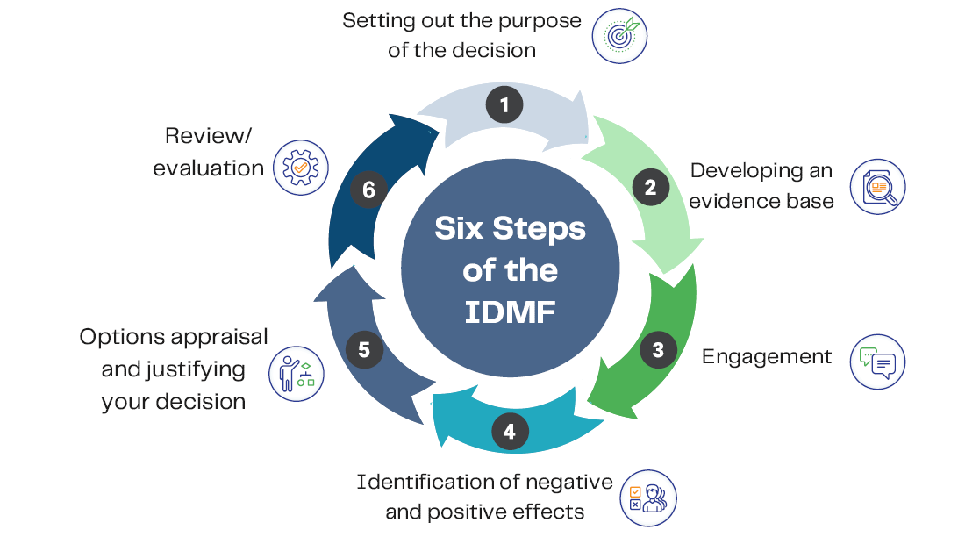

Step 1 Setting out the purpose of the decision

A robust assessment will set out the reasons for the change, how this change can impact on protected and inclusion health groups, as well as whom it is intended to benefit, and the intended outcome. Decision makers should also think about how individual proposals might relate to one another. This is because a series of changes to different services could have a severe impact on particular protected characteristics and inclusion health groups. Joint working with partners will also help us to
consider thoroughly the impact of joint decisions on the people we collectively serve.

Step 2 Developing evidence base

It is important to consider the information and research already available locally and nationally. The assessment of the effect of a change on equality and inclusion health groups should be underpinned by up-to-date and reliable information about the different groups of people that the change is likely to have an impact on. For example, workforce dashboard data and Public Health England dashboards
reporting on health inequalities. A lack of information would not be a sufficient reason to conclude that there is no impact.

Step 3 Engagement
Engagement is crucial to assessing the effect of a change on equality and inclusion health groups. There is an explicit requirement to engage people under the duty to reduce health inequalities, and beyond the legislative imperative it will help our teams to improve the equality, diversity and inclusion information that they use to understand the possible effect of a change or service improvement on diverse groups. No-one can give better insight into how proposed changes will have an impact than the people who would be affected by change.

Step 4 Identification of positive and negative effects

It is not sufficient to state simply that a change will impact on everyone equally. There should be a more in-depth consideration of available evidence to see if particular protected characteristic and inclusion health groups are more likely to be affected than others. Equal treatment does not always produce equal outcomes, and sometimes organisations will have to take particular steps for certain groups to address an existing disadvantage or to meet differing needs. This could be using proportional universalism or positive action.

Step 5 Options appraisal and justifying your decision

The assessment should clearly identify the option(s) chosen, and their potential implications, and document the reasons for the decision(s).

Step 6 Review/Evaluation

Although assessments of the effect on of a change on equality and inclusion groups will help to anticipate the likely effect on different communities and groups, in reality the full impact of a decision will only be known once it is introduced. It is therefore important to set out arrangements for reviewing the actual impact of a change once it has been implemented.

In 2023, we embedded the IDMF into our Stage 2 Equality Impact Assessment/Analysis (EIA). The assessment incorporates the 6 steps noted above.

Equality Impact Assessment/Analysis (EIA) incorporating the Inclusive Decision-Making Framework (IDMF)
Equality Impact Assessments/analysis enables the ICB to show ‘due regard’ to the Public Sector Equality Duty and ensures that consideration is given prior to any policy or commissioning decision made by the Governing Bodies (or other committees) that may impact upon the equality and human rights of people with protected characteristics.
Most of our proposed services, polices and functions are subject to an EIA. This includes (but is not limited to) service and policy planning and review, projects and work programmes, performance management, (de) commissioning and procurement, budget planning and allocation, employee performance, development and relations.
The ICB uses a Stage 1 Equality Impact Assessment (EIA) for screening purposes. Since April 2025 we have been using a simplified stage 1 template and piloted it within the ICB. The feedback has been very positive so far.
If a stage two (or part B) assessment is required, the ICB uses a more detailed word template called the Inclusive Decision-Making Framework (IDMF) Equality Analysis. This has been developed by Leicestershire Partnership Trust working in collaboration with the ICB with the aim of de-biasing the decision-making process. We are currently working to get other system partners on board.
The assessment also incorporates the Health Equity Assessment Tool (HEAT) and means that the equality analysis goes beyond the legal duties under the Public Sector Equality Duty by assessing the impact of proposals and decisions on groups in society who are more likely to experience health inequalities and/or poorer health outcomes due to wider determinants of health such as income, social and/or cultural status.
The use of the IDMF Equality Analysis received a special mention in the NHSE – Annual assessment of ICB performance. Published 17 December 2025.

In 2023 the ICB developed a joint Equality Impact Assessment and Quality Impact Assessment Policy (EQIA) with links to relevant resources and templates. The policy is also aligned to national guidance.

Analysis of EIAs undertaken (or being considered) from 1st April 2025 to 31st March 2026

Commissioning / Project
- Post operative support for self-funded bariatric surgery
- LLR Primary Care Training Hub
- LLR COVID-19 Vaccination Programme March 2025
- Prescriptions for Multi-Compartment Compliance Aids (MCAs)
- Oral Nutritional Supplement Replacement in Care Homes
- Royal Voluntary Service – Home from Hospital
- Mental Health Wellbeing Recovery and Support Service
- Management of Change
- Application to merge three GMS contracts to one for: C82059 (Westcotes GP1), C82653 (Westcotes GP2) and C82620 (Dr S Shafi (Briton Street))
- Children and Young People (C&YP) Complications from Excess Weight (CEW) Clinics Service
- S117 Overdue Annual Reviews
- S117 Discharge Reviews
- Any Qualified Provider Framework Review
- AQP Framework Spending Cap
- Shared Care – ceasing current arrangements
- LD Pooled Budget – finances, case load and management fee.
- Patient Transport
- Review of Local Authority Brokerage of Domiciliary Care Services
- General Practice Requests for Advice and Guidance – Enhanced Service
- Hybrid Closed Loop - Artificial Pancreas used for Diabetes Management
- Talking Therapies (+ 2-year extension)
- Acquired Brain Injury Pathway
- Early Onset Type 2 Diabetes in Young Adults
- Commissioning Cataract Activity
- Bullen Healthcare Ltd Appliance Prescription Management Service (Appliance Hub and Patient Review Service)
- Sexual Misconduct policy
- Mandatory Training Policy
- Recommissioning of the Maternity and Neonatal Voices Partnership
- Intermediate Care Jointly Commissioned High Dependency Service Procurement
- 8.5 Pathway Redesign: Fast Track End of Life
- Age UK Discretionary Grant
- Mutually Agreed Resignation Scheme
- Legacy Local Enhanced Service (LES) - Intraocular Pressure Assessments (IOP) Pilot
- Seasonal Vaccination

- Outpatients parenteral antimicrobial therapy
- Pulmonary Rehab Funding
- Cardiac Rehab Funding
- Community Care Funding Agreements 2026.28
- HPV vaccination
- Maternal RVN Vaccination Project
- Hinckley Day Case Unit
- Voluntary Redundancy Scheme
- Management of Change New Ways of Working
- New Dementia Support Service
- Long Covid Service
- Pre-Hospital Model of Care
- St Marys Birthing Centre
- Section 117 of the Mental Health Act transfer of services to Leicestershire Partnership Trust
- Review of Over the Counter (OTC) and Self-Care Prescribing in Primary Care​

Equality Impact Assessments are available on request by emailing:
llricb-llr.enquiries@nhs.net
Good practice EIAs are also available form the LLR ICB Websites Equalities page LINK: Equality, Diversity and Inclusion - LLR ICB

Additional EIA/Equality Analysis Training
Staff can access one-to-one training and support for completing Equality, Impact Assessments from the Equality, Diversity and Inclusion Business Partner upon request.

Specific and Measurable Equality Objectives 2024-2025/26

In 2022 - 2023 the ICB aligned their overarching equality objectives to the three themes in the Equality Delivery System (EDS) 2022 – see below. Following previous EDS assessments and data analysis from other workstreams we have developed 3 specific and measurable objectives for the next two reporting years specific to the ICB. 2026-27 is likely to be a year of reflection as we move towards clustering arrangements.
In addition, we will be delivering a number of other actions and objectives some of which are noted in the forward plan attached to this report.
Protected  Characteristic | Baseline | Our high impact actions | How will we know we’ve been successful | Who will lead on this work | When | What was achieved in 2024-26
Equality Objective 1 (Workforce)  Disability, Race and Sexual Orientation | The following percentages of staff have not shared their protected characteristic (or it is not known) on ESR.  - Race 12.4%  - Sexual Orientation 28%  - Disability 12.1% %  (Data as of Sept 2023 & 2024) | We will deliver a campaign to increase recording on ESR of all staff but with a particular focus on the protected groups listed in the first column. This will help with workforce planning.  Action links to workstreams WRES/WDES/Workforce data /New internal People Plan/NHS EDI Improvement plan and EDS Domain 2A) | We will decrease the ‘not known rates’ for each protected characteristic by:  - Race 100% to 0  - Sexual Orientation by 70% to 8.4%  - Disability by 90% to 1.2% | EDI Business Partner/ Senior OD and Workforce Manager | First measure of progress in March 2025.  This we be measured again in March 2026 | In 24/25 the number of people who shared their race status increased by 0.6% Those not declaring was 11.8%.  In  25/26 this reduced further to  9.6%  In 24/25 the number of people sharing their sexual orientation status increased by 3%. Those not declaring was 25%.  In 25/6 this was improved to 21%  In 24/25 the number of people declaring their disability status increased by 2.1 % Those not declaring was 10%.  In 2025/6 the figure was the same.
Protected  Characteristic | Baseline | Our high impact actions | How will we know we’ve been successful | Who will lead on this work | When | What was achieved 2024-26
Equality Objective 2 (Leadership)  Disability, Gender Identity, Race, Sex, Sexual Orientation, Religion & Belief | ICB Board Representation.  52.9% of voting board members did not register their ethnicity.  47% of voting members did not declare their disability status.  Lower levels of declaration are partly caused by the fact that not all ICB Board members are on the NHS Electronic Staff Record system. | To expand the characteristics declared beyond race/disability and improve the Board data collection by writing to members in a sensitive way.  Actions links to workstreams WRES/WDES Action plan/NHS EDI Improvement plan and EDS Domain 3C) | a) All Members have completed their details relating to their protected characteristics to 100%.  b) To analysis the data around declaration/sharing rates to see if there are areas for improvement. | Alice McGee, Chief People Officer | a) March 2024  b) March 2025  This we be measured again in March 2026 | In 2024 we improved on the number of voting members not declaring their race status by 10.8% to 42.1%.  In 2025 this improved to 39%  All Executive members have declared their race status.  In 2024 we improved on the number of voting members not declaring their disability status by 10% to 37%  In 2025 this improved to 33%  All the Executive Board members have now declared whether or not they have a disability.
Protected  Characteristic | Baseline | Our high impact actions | How will we know we’ve been successful | Who will lead on this work | When
Equality Objective 3 (Commissioned Services) ICB specific  Age  Sex | Bowel Cancer uptake rates for patients aged 60-74 for LLR - Latest data we have is up to April 2025 and is split as below:  LLR; 70.4%  Leic City; 56.9%  E. Leics & Rutland; 75.6%  W. Leics; 75.2% | Train a cohort of Somali Community Bowel Cancer Champions.  Run a series of bowel cancer awareness events in specific areas where uptake of screening is low, and mortality is high.  Produce a series of videos in different languages on successfully completing the bowel screening process. | - Increase one-year survival from lower GI Cancer in Men in Leicester from 69% to 72% by Sept 2026  - Increase Bowel screening up take from 45% to 50% in Leicester city by Sept 2026  - All Core 20 Connectors/Somali Health Champions and Social Prescriber Link Workers (SPLWs) to have accessed training on the screening programme.  - A minimum of one health event with screening support held in 2025-26 in each of the low uptake PCNs.  - Minimum of two Learning Disability-specific knowledge events held online/Face 2 Face during 2025-26  - Obtain Armed Forces Community agreement to host video on a website. | Head of PHM and ICB Cancer Lead | Sept 2026  Sept 2026  Sept 2026  Sept 2026

Equality Delivery System (EDS)

The EDS is the foundation of equality improvement within the NHS. It is an accountable improvement tool for NHS organisations in England - in active conversations with patients, public, staff, staff networks and trade unions - to review and develop their services, workforces, and leadership. It is driven by evidence and insight. This is the third version of EDS and was commissioned by NHS England and NHS Improvement supported by the NHS Equality and Diversity Council (EDC). It is a simplified and easier-to-use version of EDS2.

The EDS comprises eleven outcomes spread across three Domains, which are:

Domain 1 - Commissioned or provided services.
Domain 2 - Workforce health and well-being
Domain 3 - Inclusive leadership.

The outcomes are evaluated, scored, and rated using available evidence and insight. All the scores from the three domains are required to produce a final rating. Domain 1 is determined by using the middle score out of the three services from Domain 1, in line with the EDS Technical Guidance EDS Technical Guidance. It is these ratings that provide assurance or point to the need for improvement.

Domain 1 requires implementation at system level. It must be applied to three clinical services or pathways selected from the local system partner NHS organisations. Domains 2 and 3, on the other hand, must be completed at local organisational level and led by individual NHS organisations.

The 2025-26 EDS evaluation was paused due to the ongoing changes to ICBs.

Previous reports can be found on the ICB Website.
LINK: https://leicesterleicestershireandrutland.icb.nhs.uk/equality-statement/

Website Accessibility Standard

The Public Sector Bodies (Website and Mobile Applications No. 2) Accessibility Regulations 2018 builds on existing obligations to make ‘reasonable adjustments’ under the Equality Act, and public sector bodies must make their websites and apps more accessible by making them ‘perceivable, operable, understandable and robust’. This regulation also includes internal websites such as intranets.

The LLR ICB (and providers) websites should contain clear accessibility statements to ensure that the population can access information, resources and documents from the ICB in a format that meets their needs, for example via easy read or large print formats. Where possible, information resources and publications hosted on the ICB website are presented in plain and easy to understand language.
For a copy of the ICB website accessibility statement please click on the following link: Accessibility Statement - LLR ICB

Accessible Information Standard (AIS) 2016
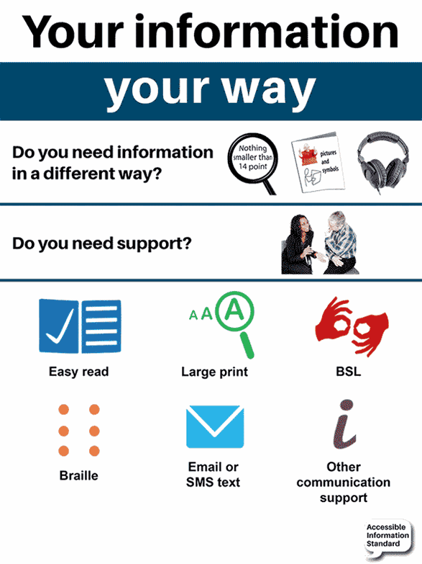
The aim of the Accessible Information Standard (AIS) is to make sure that people who have a disability, impairment or sensory loss receive information in the best format for them and receive any communication support that they may require.
The AIS applies to service providers across the NHS and adult social care system, and effective implementation requires such organisations to make changes to policy, procedure, human behaviour and, where applicable, electronic systems.
Commissioners of NHS services and publicly funded adult social care must show due regard to this standard, to ensure that they enable and support compliance through their relationships with provider organisations. This standard is in all the ICBs NHS Standard Contracts and is monitored by Quality and Performance Key Performance Indicators (KPIs).
The Accessible Information Standard was updated in June 2025. Further information about the updated Accessible Information Standard can be found on the following link: NHS England website.
A copy of LLR ICBs AIS statement can by clicking on the following link: Accessible Information Statement

Provider Compliance Audit 2025-2026
The ICB conducts a desktop provider compliance check of commissioned service provider websites on the following equality-related legal duties and NHS Mandated Standards:
- Equality Objectives published on the provider’s website (reviewed every 4 years)
- Published Equality information – e.g., Equality Compliance
- Workforce Race Equality Standard Report (on an annual basis)
- Workforce Disability Standard Report (on an annual basis)
- Up to date Modern Slavery Act 2015 Statement on website (for providers of £36 million and over – on an annual basis)
- Website Accessibility Statement -– see above for more information on what these are.
- The Gender Pay Gap

The table below shows a summary of an analyses carried out in December 2025. The following providers were reviewed:

- East Midlands Ambulance Service (EMAS)
- Leicestershire Partnership NHS Trust
- University Hospitals Leicester (UHL)

Commissioned Provider | Equality Objectives | Published Equality Information | Published WRES report | Published WDES report | Modern Slavery Act | Gender Pay Gap
East Midlands Ambulance Service (EMAS)
Leicestershire Partnership NHS Trust
University Hospitals Leicester (UHL)
KEY
In place on website or confirmed as complete
Not up to date/not dated

Our Workforce (including other relevant statutory & mandated duties)
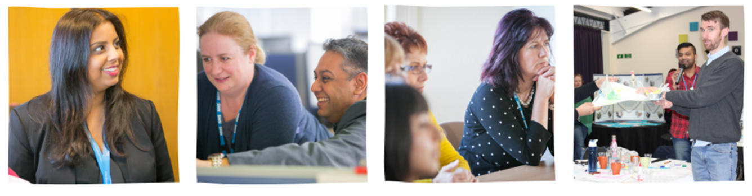As an employer we aim to build a great place to work. With a culture of inclusive and compassionate leadership, we strive to create a working environment where all our staff feel included, valued and can fulfil their potential.
The organisation has robust policies and procedures in place to support the fair and equitable treatment of all staff. Some examples are included in the ‘Support for staff’ section. The ICB is committed to advancing equality of opportunity for all current and potential employees.
People Plan

The NHS is made up of 1.3 million employees who care for the people of this country with skill, compassion, and dedication. People work in many different roles, in different settings, employed in different ways, and in a wide range of organisations.

The NHS People Plan was published in July 2020 and sets out actions to support transformation across the whole NHS now and in the future. It focuses on how we must all continue to look after each other and foster a culture of inclusion and belonging, as well as grow our workforce, train people, and work together differently to deliver patient care.

The NHS People Plan is set out in four broad themes:

- Belonging in the NHS
- New ways of working and delivering care
- Growing for the future
- Looking after our staff

The ICB continues to undertake initiatives both organisationally, and with system partners, to advance the above aims.

The People Plan sets out what NHS staff can expect from leaders and each other and includes a focus on fostering a culture of inclusion and belonging. Some of the relevant actions are found in our Workforce Equality, Diversity and Inclusion Improvement Plan. The NHS People Plan includes a People Promise, which outlines the actions and behaviours staff should expect from their employers and colleagues, as part of improving the experience of working in the NHS for everyone.
The Inclusive People Promise

Equality, Diversity, and Inclusion runs throughout the People Plan, changing the culture of NHS services to focus more on learning, belonging, recognition, work life balance, mental health and wellbeing and being the best place for people to work. Details of the inclusive people promise are shown below:

We are a team

- First and foremost, we are one huge, diverse and growing team, united by a desire to provide the very best we can.
- We learn from each other, support each other and take time to celebrate successes.

We work flexibly

- We do not have to sacrifice our family, our friends or our interests for work.
- We have predictable and flexible working patterns, and, if we do need to take time off, we are supported to do so.

We are always learning

- Opportunities to learn and develop are plentiful, and we are all supported to reach our potential.
- We have equal access to opportunities.
- We attract, develop and retain talented people from all backgrounds.

We are safe and healthy

- We look after ourselves and each other.
- Wellbeing is our business and our priority, and if we are unwell, we are supported to get the help we need.
- We have what we need to deliver the best possible care –from clean safe spaces to rest in, to the right technology.

We each have a voice that counts

- We all feel safe and confident to speak up.
- We take the time to really listen to understand the hopes and fears that lie behind the words.

We are recognised and rewarded

- A simple thank you for our day-to-day work, formal recognition for our dedication, and fair salary for our contribution.

We are compassionate and inclusive

- We do not tolerate any form of discrimination, bullying or violence.
- We are open and inclusive.
- We make the NHS a place where we all feel we belong.

The NHS Long Term Workforce Plan

The NHS Long Term Workforce Plan was published in June 2023 and identifies three key themes of train, retain and reform to support the growth of the NHS workforce for the future.

Train

LLR ICB will work in conjunction with the Integrated Care System (ICS) to provide a pathway of Apprenticeships into Health & Social Care, Primary and Secondary Care, Voluntary, Community and Social Enterprise to ensure we engage local opportunities into health and care careers both clinical and non-clinical. Planned Higher Education Institute (HEI) commissioned clinical education programmes and higher clinical apprenticeships - foundation degree, degree and Master accredited courses.

Retain

The retention of our workforce to be healthy and well, within a culture that provides opportunity to be supported and provide educational competence and confidence, to meet the population health needs and improve access and minimise health inequalities.

Reform

LLR ICB lead the Place and Neighbourhood approach to access, supply and quality of our workforce and how care is delivered to our population through the upskilling the workforce and have the supervision, coaching and mentorship.

From the three areas of workforce priorities, we will enable and influence positive progression across partnerships and maximising funding models, enriched with appraisal conversations, new models of workforce to meet the health needs of our population and the vision for LLR Integrated Care System (ICS) and Integrated Care Partnerships (ICP).

- NHS Equality, Diversity and Inclusion Improvement Plan

In June 2023, NHS England (NHSE) published its first Equality, Diversity, and Inclusion (EDI) Improvement Plan to improve equalities and to enhance the sense of belonging for NHS staff to improve their experience. It provides targeted actions to address the prejudice and discrimination (direct and indirect) that exists through behaviour, policies, practices and cultures against certain groups and individuals across the NHS workforce.
The improvement plan builds on the People Promise and the People Plan, using the latest data and evidence to identify six high impact actions, to address the widely known intersectional impacts of discrimination and bias, and which organisations across the NHS can take to considerably improve EDI.
The improvement plan is one of the key delivery frameworks for capturing what the ICB are doing to create an inclusive culture. For, example, the Workforce Race and Disability Standards (WRES & WDES) data feeds into this together with the relevant equalities staff survey results.
The plan was monitored through the ICBs Operational Delivery Group.
A copy of the latest updated EDI improvement plan is available on the ICB website: LINK: https://leicesterleicestershireandrutland.icb.nhs.uk/equality-statement/

Workforce Profile (compared to the 2021 census data for LLR)
Our aim is to employ a diverse workforce that is representative of our local communities as we believe this will support our decision making in the development of health services.
This section illustrates the demographics of Leicester, Leicestershire and Rutland ICB workforce as of 30th September 2025, and compares the figures to Census 2021 data from the Office of National Statistics (ONS) population of LLR local authority districts. The ICB will use this data to inform future workforce planning.

Where percentages of our workforce are low (under 5%) this can result in staff being identified. Therefore, we have not presented the data for that protected characteristic.

Age

The age-band graph above shows that the largest proportions of the Leicester, Leicestershire and Rutland ICB workforce are between the ages of 45-49 (19.8%), 50-54% (14.9%), 40-44 (13.9%) Whilst at the other end of the scale, the lowest proportions of the Leicester, Leicestershire and Rutland ICB workforce are between the ages of 16-19 (0.00%), 70 -100 (0.31%), 20-24 (1.2 %) and 65-69 (3.4%).

LLR Workforce Pay Band Cluster Table and Analysis
Age
 | % Headcount by Pay Band
Age Band | Band 1 - 4 | Band 5 - 7 | Band 8a - 9 | Non-AfC | Grand Total
16 - 19 Years Old | 0.00% | 0.00% | 0.00% | 0.00% | 0.00%
20 - 24 Years Old | 10.00% | Under 5% | 0.00% | Under 5% | 1.24%
25 - 29 Years Old | 10.00% | 6.14% | Under 5% | 0.00% | 4.02%
30 - 34 Years Old | 15.00% | 19.30% | Under 5% | Under 5% | 9.29%
35 - 39 Years Old | 10.00% | 12.28% | 11.33% | Under 5% | 10.53%
40 - 44 Years Old | 10.00% | 11.40% | 13.33% | 25.64% | 13.93%
45 - 49 Years Old | 15.00% | 15.79% | 23.33% | 20.51% | 19.81%
50 - 54 Years Old | 15.00% | 12.28% | 17.33% | 12.82% | 14.86%
55 - 59 Years Old | 10.00% | 8.77% | 15.33% | 10.26% | 12.07%
60 - 64 Years Old | 5.00% | 11.40% | 10.00% | 12.82% | 10.53%
65 - 69 Years Old | 0.00% | Under 5% | Under 5% | 7.69% | 3.41%
70 - 100 Years Old | 0.00% | 0.00% | 0.00% | Under 5% | 0.31%
Grand Total | 100.00% | 100.00% | 100.00% | 100.00% | 100.00%

- The figures in the table above illustrate that LLR ICBs 20–24-year-olds are mainly found in bands 1-4 at 10%.
- The highest proportion 25–29-year-olds are found in bands 1-4 at 10% and 5-7 at 6.1%.
- The highest proportion of 30-34 and 35- 39-year-olds are in bands 5-7 at 19.3% and 12.3% respectfully. There is also a high proportion of 35–39-year-olds in bands 8a-9 at 11.3%.
- The highest proportion of 40 - 44-year-olds are found in non AfC at 25.6% followed by bands 8a -9 at 13.3%.
- The highest proportion of 45–49-year-olds is at bands 8a-9 at 23.3% followed by non AfC at 20.5 %.
- The highest proportion of 50-54 and 55–59-year-olds is at bands 8a-9 (17.3% & 15.3%) respectively.
- The highest proportion of 60-64 and 65 -69-year-olds are found in non AfC at (12.8% and 7.7%) respectively.

Disability

The figures shown in the graph above illustrate that 80.5 % of the LLR ICB workforce identify themselves as having no disability. 9.6 % declared that they have a disability, and approx.10% opted not to disclose their disability status.

There has been a 3.3% increase in the number of people declaring that they have a disability between September 2024 and September 2025.

Local Census data shows that 83.8% report themselves as not being disabled under the Equality Act and 16.2% identify themselves as being disabled. This indicates that the ICB workforce is not reflective of the local population in relation to representation of those identifying as disabled.

LLR Workforce Pay Band Cluster Table and Analysis

Disability Status | Band 1 - 4 | Band 5 - 7 | Band 8a - 9 | Non-AfC | Grand Total
No | 75.00% | 85.09% | 84.00% | 56.41% | 80.50%
Yes | 5.00% | 10.53% | 12.00% | 0.00% | 9.60%
Not Declared | 15.00% | under 5% | under 5% | 43.59% | 9.60%
Prefer Not To Answer | 5.00% | 0.00% | 0.00% | 0.00% | 0.31%
Grand Total | 100.00% | 100.00% | 100.00% | 100.00% | 100.00%

The table above shows that those staff on non-AFC terms are least likely to have declared their disability status. There is also a higher proportion of non-disclosure at Bands 1 – 4 than those at Bands 5 – 9.

Marriage & Civil Partnership

65 % of the LLR ICB workforce identify themselves as being married, compared to 47% from the local Census.

The proportion of the LLR ICB workforce who declare themselves to be single is 22%, which is an increase of approx. 2% from 2024 This compares with 36.5% from the local Census data.

Race

90.4% of ICB staff have chosen to declare their ethnicity, which is an increase from 2% from last year. 57% of the LLR ICB workforce identify themselves as White, and 29% identify as Asian. The total Black Asian & Minority Ethnic (BME) population for the ICB workforce is 33% (the same as last year’s figures).

The local Census data indicates that 72.5% of the population are White, 19.5% Asian with the total BME population of 27.5%, demonstrating that the ICB workforce has good ethnic representation.

LLR Workforce Pay Band Cluster Table and Analysis

 | % Headcount by Pay Band
Ethnic Category | Band 1 - 4 | Band 5 - 7 | Band 8a - 9 | Non-AfC | Grand Total
White | 50.00% | 56.14% | 62.67% | 41.03% | 56.97%
Asian | 25.00% | 37.72% | 25.33% | 20.51% | 29.10%
Not Stated | 10.00% | Under 5% | 7.33% | 35.90% | 9.60%
Black | 15.00% | Under 5% | Under 5% | 0.00% | 2.17%
Mixed | 0.00% | Under 5% | Under 5% | Under 5% | 1.24%
Other | 0.00% | 0.00% | Under 5% | 0.00% | 0.62%
Chinese | 0.00% | 0.00% | Under 5% | 0.00% | 0.31%
Grand Total | 100.00% | 100.00% | 100.00% | 100.00% | 100.00%

The figures shown in the table illustrate that the highest proportion of white staff are found in band 8a -9 at 63% which is approx.1.5% less than in 2024. More Asian staff are found at bands 5-7 (38%) 8a-9 (25%) and although it is quite an even split across bands 1-4, 8a-9 and non AfC.
The non-AfC cluster also has fewer staff disclosing their ethnicity at 36%.
Figures for Black staff, Mixed Race staff, Chinese staff and other ethnicities are consistently low across all pay band clusters, with the exception of pay bands 1-4, which is made up of 15 % of Black members of staff (which is a decrease from 2024 of approx. 1.7%).

Religion & Belief

The religion and belief graph above illustrates that 26.3 of the LLR ICB workforce identify themselves as being Christian (approx. the same as 2024), 8.4% identify as Muslim (a slight increase on 2024 by 2%), and 13% as Hindu (which is comparable to the previous year). The Christian and Muslim figures are lower than the local 2021 Census, which gives results of 39.2% and 9.2% respectively. However, the number of Hindu employees is almost 5% higher than the total number of local residents identifying themselves in that category, which is 8.2%.

The proportion of the LLR ICB workforce who chose not to declare their religion is 29% an improvement of 2% on the previous year. This is nearly six times higher than the Census 2021 figure, which is 5.5%.

LLR Workforce Pay Band Cluster Table and Analysis
 | % Headcount by Pay Band
Religious Belief | Band 1 - 4 | Band 5 - 7 | Band 8a - 9 | Non-AfC | Grand Total
I do not wish to disclose my religion/belief | 30.00% | 18.42% | 26.67% | 71.79% | 29.41%
Christianity | 20.00% | 27.19% | 30.67% | 10.26% | 26.32%
Hinduism | 20.00% | 16.67% | 11.33% | 7.69% | 13.31%
Atheism | 15.00% | 10.53% | 14.00% | 10.26% | 12.38%
Islam | 10.00% | 14.91% | 5.33% | 0.00% | 8.36%
Other | 5.00% | 7.89% | 6.00% | 0.00% | 5.88%
Sikhism | 0.00% | Under 5% | 6.00% | 0.00% | 4.02%
Buddhism | 0.00% | Under 5% | 0.00% | 0.00% | 0.31%
Grand Total | 100.00% | 100.00% | 100.00% | 100.00% | 100.00%

The figures shown in the table demonstrate that a large number of staff across all bands chose not to declare their religion or belief. The highest proportion being non AfC at 72% (rounded up). The highest proportion of Christians can be found at bands 8a-9 at 31%. The highest proportion of Hindus/atheists is found at bands 1-4 at 20% & 15% respectively and those of Islamic faith are found bands 5-7 at 15%. Most of the headline figures are comparable to the previous year.

Sex

The above table illustrates that 73% of LLR ICB staff are female and 27% are men. This reflects the latest available statistics from NHS Digital, which detail that the majority of the total NHS workforce are women at 76.7%.
In contrast, local Census 2021 data shows that 49.5% of residents are male, and 50.5% are female. This also mirrors the data for both the East Midlands region and England as a whole.

The LLR Workforce Pay Band Cluster Table and Analysis for Sex/Gender can be found in the Gender Pay Gap Report.

Gender Pay Gap Report

Sexual Orientation

The sexual orientation graph above illustrates that 76 % of the LLR ICB workforce identify themselves as heterosexual or straight. This is an increase of 4% from 72% in 2023. It is lower than the 2021 Census data for LLR local authority districts, which details that 89.5% of the total resident population aged 16 and above have listed themselves in the same category.

21% of the LLR ICB workforce chose not to declare their sexual orientation status, an improvement of nearly 4% on last year’s figures. Whilst positive, it is higher than the Census 2021 data where 7.8% chose not to answer this question on their census form.

LLR Workforce Pay Band Cluster Table and Analysis
 | % Headcount by Pay Band
Sexual Orientation | Band 1 - 4 | Band 5 - 7 | Band 8a - 9 | Non-AfC | Grand Total
Heterosexual or Straight | 65.00% | 85.96% | 81.33% | 30.77% | 75.85%
Not stated (person asked but declined to provide a response) | 30.00% | 10.53% | 15.33% | 69.23% | 21.05%
Bisexual | 0.00% | Under 5% | Under 5% | 0.00% | 0.93%
Other sexual orientation not listed | 0.00% | Under 5% | Under 5% | 0.00% | 0.93%
Gay or Lesbian | 0.00% | 0.00% | Under 5% | 0.00% | 0.93%
Undecided | 5.00% | 0.00% | 0.00% | 0.00% | 0.31%
Grand Total | 100.00% | 100.00% | 100.00% | 100.00% | 100.00%

The figures shown in the table above illustrate that the LLR ICB workforce has a consistent majority identifying themselves as being heterosexual or straight across all pay bands, with the exception of the Non-AfC cluster at 31%. The Non-AfC cluster also has a larger proportion of staff opting not to disclose their sexual orientation status. This is approx. a 2.5% improvement on the 2024 figures. The proportions of bisexual, other, gay or lesbian, and undecided members of staff are consistently low across all pay band clusters.

Contract Status

The figures are roughly comparable to 2024.

LLR Workforce Pay Band Cluster Table and Analysis
 | % Headcount by Pay Band
Contract Status | Band 1 – 4 | Band 5 - 7 | Band 8a - 9 | Non-AfC | Grand Total
Full-Time | 75.00% | 78.95% | 74.67% | 17.95% | 69.35%
Part-Time | 25.00% | 21.05% | 25.33% | 82.05% | 30.65%
Grand Total | 100.00% | 100.00% | 100.00% | 100.00% | 100.00%

The figures indicate that highest number of part time workers are found in non AfC band at 82.05%. The lowest number of full-time workers is found in non AfC at 17.95% with an even split across the other bands.

Workforce Race Equality Standard (WRES). Not a mandated requirement for ICBs in 2025/6
At present, Integrated Care Boards (ICBs) are not required to undertake the WRES assessment. However, we still analyse the data and use this to report into the EDI Improvement Plan and Equality Delivery System (EDS) evidence for example which can be found on our website.
LINK https://leicesterleicestershireandrutland.icb.nhs.uk/equality-statement/

This information helps us to fully understand the diversity of our workforce to ensure non-discriminatory practice, work with staff and staff representatives. Using the data from the standard and integrating this into our EDI Improvement Plan and Equality Delivery System helps identify and eliminate barriers and discrimination in line with the Public Sector Equality Duty (PSED), the Equality Act 2010 and Employment Statutory Code of Practice. Ultimately, it is about ensuring an inclusive approach with regards to recruitment, training, development and promotion.
We also meet our requirements of the ICB Assurance Framework, which means monitoring and supporting NHS and other large provider organisations with progression of the Standard.

Workforce Disability Equality Standard (WDES). Not a mandated requirement for ICBs in 2025/6

The Workforce Disability Equality Standard (WDES) was introduced in April 2019 as a mandated data collection for NHS provider trusts. The WDES is a collection of 10 metrics that aim to compare the workplace and career experiences of disabled and non-disabled staff. NHS Trusts and Foundation Trusts are required to report and publish data, on an annual basis, for each of these metrics.

At present, Integrated Care Boards (ICBs) are not required to undertake the WDES assessment. However, as with the WRES, we still analyse all the data and use this to report into the EDI Improvement Plan and Equality Delivery System evidence.

LINK: EDI-Improvement-Plan230625

The Gender Pay Gap Reporting

The specific duty regulations contain an obligation for public bodies with 250 or more staff to publish gender pay gap information each year. This duty to publish applied to ICBs from 30 March 2024. A copy of the 2025- 26 report can be found by clicking on the following link:
LLR-ICB-Gender-Pay-Gap-Report-2025-2026

Training and Development Opportunities

Welcome sessions (paused at time of writing)

The aim of these sessions is to welcome new starters to the LLR ICB and to provide them an overview of who we are, the system that we are operating in, what they can expect from working for us as well as signposting to useful information. The welcome sessions include an EDI workshop exploring people’s knowledge, and explaining the basic concepts, relevant legislation and organisational requirements.

EDI Mandatory training

LLR ICB staff are required to complete an on-line EDI training module every 3 years which is accessed via the Electronic Staff Record (ESR). The table below shows the level of compliance for all ICB staff including lay members as of January 2026:

Competency | All Workers |  | All Employees (Workers excluding GP / Lay Members)
Competency | Match | No Match | Match | No Match
NHS|CSTF| Equality, Diversity and Human Rights - 3 Years| | 91.8%, | 8.02% | 94.86%, | 5.14%

Details of other training and development can be found in the section working in collaboration with LLR System Partners.
Looking after our workforce Health and Wellbeing
Our purpose is to champion better work/life balance for everyone. The ICB takes active steps to support the health and wellbeing of our colleagues through initiatives such as organisation-wide Health and Wellbeing events, promoting a healthy work/life balance and health and wellbeing initiatives.

Included here are a few examples of the work we are doing to support the health and wellbeing of staff.

- Employee Assistance Programme

Our Employee Assistance/Counselling is provided by AMICA, who offer a confidential telephone counselling service for a range of issues and can also provide face-to-face specialist assistance if recommended by a counsellor.

Ways to contact Amica
Telephone | 0116 254 4388 (24/7 service)
Live Chat | https://go.crisp.chat/chat/embed/?website_id=59ab96f7-928c-480f-8a7a-b6a0939de2e4
Contact form | https://www.amica-counselling.uk/contact-us/

- Employee Benefits schemes started in June 2024

Access for ICB staff to a range of benefits built to boost mental, physical, and financial wellbeing.

The ICB partnered with Vivup, one of the UK’s leading employee benefits and wellbeing providers, to bring employees exciting perks:

Vivup highfive: From applauding achievements to sending a simple thank you for a job well done, Vivup highfive lets staff celebrate colleagues in a few quick clicks. See it, say it, celebrate it with highfive.

Lifestyle savings: From shrinking supermarket shopping bills to enjoying money off at the movies, staff can spend less on the things that matter most with a wide range of discounts from the UK’s leading retailers.

Home and Electronics: Heling to spread the cost on lots of must-have items fulfilled by John Lewis & Partners and Curry’s - including the latest tech, gaming essentials, domestic appliances, toys, furniture, DIY tools, and more.

- Financial Wellbeing and pensions support can be provided through Affinity helping colleagues to understand the support available as well as the changes to the NHS Pension and how this might affect them.

- Family Friendly Policies and Practices
Policies such as the Flexible Working Policy, Agile Working Policy, Special Leave Policy, Family Leave Policy, and being a fostering friendly workplace all have a positive impact on the work/life balance of our staff and enable us to support working parents to manage work alongside their family and caring commitments.

- LLR Leadership Conference: Leading with Care During Turbulent Times Advertised to LLR ICB Staff.
The LLR Leadership Conference: Leading with Care During Turbulent Times took place on 10 September 2025 and brought together 173 attendees including leaders and managers from more than 15 organisations across health, social care, emergency services, local authority and the VCSE sector- the conference was also extended to Northamptonshire colleagues.

The two-hour virtual event focused on strengthening compassionate and resilient leadership during a period of significant pressure and uncertainty across the system.
Delegates heard powerful opening and closing reflections from Alice McGee (Chief People Officer, LLR ICB) and Shirly Way (Head of Area, Skills for Care), framing the importance of leading with authenticity, care and confidence amid change.

Three focused masterclasses were delivered:
- Looking after your team – Strategies to foster a healthy, supported team environment. Delivered by Healthy Workplaces Leicestershire
- Looking after you as a manager – Tools to support your own wellbeing and resilience as a manager. Delivered by the LLR Leadership Conference Team
- Difficult Conversations & Employment Support – Practical guidance for navigating difficult conversations, change, and uncertainty, including redundancy and employment matters. Delivered by LLR Vita Health Group.

The conference created a reflective and supportive space for colleagues to reconnect with their leadership purpose and explore actionable approaches to supporting both themselves and their teams to lead with care through turbulent times. Feedback from attendees highlighted strong engagement, relevance of content and the value of cross-sector learning. 98% would consider attending another event (44 total feedback forms).
The event successfully contributed to a system-wide commitment to building compassionate workplaces and creating more good days for leaders and teams across LLR. A takeaway toolkit (see Link Below) was created to provide delegates with practical, accessible resources that extend the learning from the session and support ongoing compassionate leadership, effective communication, and wellbeing in their everyday roles.

LINK: takeaway toolkit

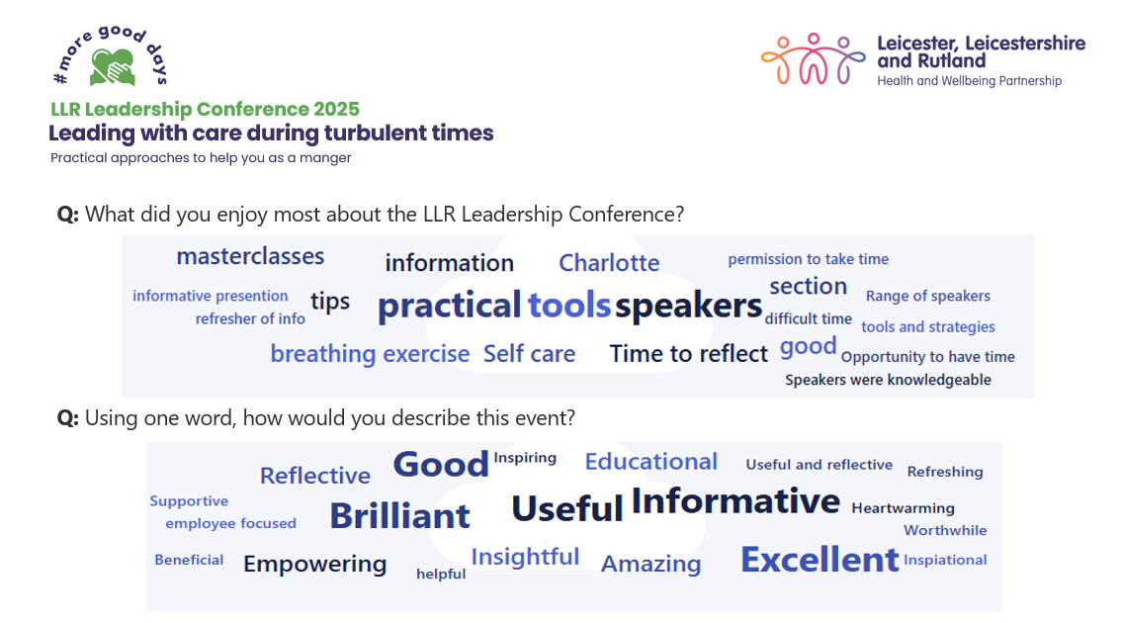

- Menopause, Coffee and Chat
The Midlands Leadership Academy hold a bi-monthly Menopause, coffee and chat session from 12.30pm to 13.30pm for any women wishing to go along have a chat with other Midlands NHS colleagues also going through the menopause.

- Mental Health First Aiders
Across the ICB there are a number of staff who are accredited Mental Health First Aiders, which means they are equipped with the skills to support other colleagues in the workplace who may be feeling low, anxious or anyone who has a general mental health and wellbeing worry.
These colleagues meet quarterly in a community of practice and are supporting the quarterly health and wellbeing stall.

- NHS LLR Talking Therapies – Vita Health Group
This is for staff struggling with depression, anxiety, excessive worry, or low mood.

Working in partnership with the NHS, Vita provides talking therapy services, and can provide advice and guidance on the best options for our staff.

- The Joy app
This app allows people to search for local services. There are a variety of different offerings depending on what location you set from memory cafes, employment cafes, housing support to name a few.

LINK: Joy (thejoyapp.com)

- National Pulse Survey and National Staff survey
The ICB takes part in the nation quarterly Pulse survey and the annual national Staff Survey they consistently have questions on health and wellbeing allowing the ICB to respond as needed.

- People Information Board
Within the office environment a People Information board has been created which showcases initiatives internally, locally, regionally and nationally to support colleagues’ wellbeing.

- Continuous Quality Improvement Signposting Board
Continuous Quality Improvement (CQI) activity has continued this year enabling teams to reflect on and improve their work systems, helping to foster autonomy, psychological safety, and job satisfaction. A CQI signposting board has been introduced within the ICB office to showcase projects across the ICB and LLR, share learning, inspire colleagues, and promote development opportunities, training, events, along with displaying clear points of contact for CQI leads.

Looking after our Workforce (Policies)
We have several policies in place to support staff when they have a concern about abuse, harassment, bullying or violence. Equality Impact Assessments were recently undertaken on the following policies:
- Grievance Policy
- Harassment and Bullying at Work Policy
- Health & Wellbeing Policy
- Freedom to Speak up Policy.
- New: Sexual Misconduct Policy

The ICB introduced a Sexual Misconduct Policy in 2025, in line with the Sexual Safety in Healthcare Organisation Charter and national NHS guidance and employment law.

- NEW: Zero-Tolerance Statement


We worked with our colleagues to develop a Zero-Tolerance Statement because we believe that everyone should be treated with dignity and respect and free from any form of harmful behaviour. The statement demonstrates the importance of positive and respectful behaviours and provides reassurance to colleagues that unacceptable behaviour will be addressed.

Looking after our Workforce (Staff Networks/Champions)
- LLR ICB People Forum

Since July 2023 the ICB has been running a staff network meeting called the ‘People Forum’. The Forum represents all staff in the ICB with members from each directorate. The aims are:

- A place to discuss opportunities and challenges as well as providing feedback and having the opportunity to share views.
- Providing a safe space for discussion, sharing ideas and progressing key pieces of work.
- Building on direct feedback from colleagues as well as feedback from surveys.
- Role modelling the ICB values and provide positive energy to drive forward innovations.
- Working alongside other people groups to support and avoid duplication of work. An example of this is the appraisal champions. network and people champions.

To support the People Forum there are several People Champions from across the Directorates.

- Support for Carers

We have supported colleagues to establish a conversation group called ‘Care for a Cuppa’, which provides a safe space for working carers to connect.

Lindsay Widdowson - who set up the group - says ‘talking about the challenges we face isn’t always easy, but it is always important. Being vulnerable takes courage. But it’s in those honest moments that real strength is found – strength to connect, share, and support each other towards better wellbeing. As well as talking, sharing and supporting each other we also invite speakers to have a conversation about the things that matter most’.

- Freedom to Speak Up Champions

Across our ICB we have launched our network of Freedom to Speak Champions. The aim of our network is to encourage a range of colleagues to speak up – particularly groups who might find it more difficult to speak up with a strong focus on different service areas, professions, and protected characteristics.

Our champions are impartial and confidential, offering encouragement and signposting to the appropriate avenue for colleagues.

- Appraisal Champions Network

To support staff development following on from previous staff survey results a network meeting has been established to educate a number of employees and become “appraisal champions” to increase the uptake and recording of appraisals.

- Appraisal Champions have played an active role in supporting colleagues through the appraisal process and in reshaping the culture around how appraisals are perceived.

- The network meets quarterly to share best practices, provide updates, address concerns and challenges, review appraisal data, and discuss ways to advance the appraisal agenda.

Support for Staff during the Restructure

(This includes the relevant health and wellbeing support together with the workforce support previously mentioned).

The ICB have provided extra support for all staff during this difficult time. This included:

A Mutually Agreed Resignation Scheme

A Voluntary Redundancy Scheme
- Extra support for staff who are at risk of redundancy or had taken MARs/voluntary redundancy to access relevant skills training (e.g., CV / application writing, interview skills and other support such as counselling and pension workshops).
- Job Centre support for those taking Voluntary Redundancy
- Clear guidance for affected staff on how to appeal selection decisions and / or selection for redundancy under the relevant policy (e.g., Grievance Policy / Organisational Change Policy).
- Considerations and adjustments for those absent from work during the management of change process (e.g., maternity leave, planned or unplanned sickness absence).

- Consideration of existing or requested flexible working arrangements during the selection process.
- Drop-in sessions for managers on people and processes.

- Inclusive recruitment training for recruiting managers being developed at time of writing.

- Equality Impact Assessments being carried out on the implications regarding the ICB workforce.

Communication with Staff, Partners and Diverse Communities

Our communication is impactful, proactive and developed with audiences in mind. Whether we are communicating with our staff, partners or stakeholders, the most suitable communication channels are used to inform, support, influence and engage patients, communities, key stakeholders including system partners, as well as our staff.

Our channels and communications support include:
- LLR ICB website for patients, partners, stakeholders and communities.
- Five for Friday – the ICB’s stakeholder bulletin, featuring the week’s top five articles for our partners and stakeholders.
- Other regular updates to key stakeholders on NHS initiatives.
- Various webinars to support communities on specific conditions.
- Communications support for Women in Leadership Conference.
- Communications support for ICB Annual General Meetings.
- Communications support for ICB Annual Report.
- Social media (Facebook, Instagram, X (former Twitter), YouTube, LinkedIn and TikTok for instantaneous news and advice.
- LLR Connect – the ICB intranet for staff, offering an online one-stop shop for news, staff directory, health and wellbeing support, training opportunities and more.
- LLR Connect News – our fortnightly staff newsletter.
- Weekly Joint Executive Team (JET) summary – sent to Executive Directors, Operational Delivery Group (ODG) and other senior managers with a summary of key communications and engagement activities, as well as a forward look.
- Regular ICS updates issued across the LLR health and care system.
- Weekly meetings chaired by ICB with system Communication and Engagement partners.
- Campaigns and toolkits issued to ICS partners, MPs and wider stakeholders, including communities voluntary and community sector (VCS) to boost engagement and partnership working.
- Monthly staff briefings (virtual and in person).
- Regular team meetings.
- Ad-hoc online briefings for staff covering urgent important news.
- Directorate days/meetings.
- Pulse Survey.
- Annual Staff Survey.
- Ad-hoc survey and supportive communications for staff on EDI issues (e.g. racist attacks that took place in parts of the country in 2024), offering support to staff and gathering feedback on their experiences, support requirements and suggestions.
- Ad-hoc emails communications to all staff with timely updates.
- Regular communication and support for Primary Care including a GP newsletter.
- MP briefings.
- People Information Board.

We regularly share equality awareness articles in our staff newsletters, on our intranet and through our range of internal and external corporate channels and networks.

The information we populate, supports the ICB to raise the profile of key dates that are important and relevant to people and communities across LLR and the UK. Our activities enable the ICB to support and promote local awareness days, weeks and events, including religious festivals and events marked or celebrated by marginalised groups, ensuring we are inclusive of all groups and communities.
During the reporting period the ICB has promoted a range of events that promote awareness and celebration of protected characteristics and other groups including (but not limited to):
- Diwali, Navratri, Christmas, Vaisakhi, Bandi Chhor Divas, Ramadan (including information for diabetics), Eid, Chinese New Year and Holocaust Memorial Day - all featured in internal and external bulletins, as well as on social media.
- Men’s Health week: 9-15 June 2025
- Pride Month June 2025
- Speak Up Month October 2025
- Black History Month October 2025
- The Oliver McGowan Mandatory training in LLR
- Leicester’s Diwali celebrations on the Golden Mile in October 2025, shared on social media and in Five for Friday. Additionally, an internal message from Toby Sanders, Chief Executive, circulated to all staff.
- World Mental Health Day: 10 October 2025 (prioritising mental health in the workplace.
- Disability History Month: November 2025
- International Women’s Day: 8 March 2026
- Women In Leadership Conference: 10 March 2026
By promoting and hosting inclusive events, we are actively contributing to positive workplace cultures and fostering community spirit. We will continue to celebrate diversity, ensuring our communication and engagement is sustainable and a catalyst for social and community cohesion.

Working in Collaboration with LLR/Regional Partners

The national direction regarding people development has provided LLR with an opportunity to collaborate and co-design people development practices that will enable LLR ICB and system workforces to be supported and developed with a cohesive and consistent approach. The cross-system development approach affords a valuable opportunity to share, design and deliver resource via the LLR Academy.

LLR systemwide Equality, Diversity and Inclusion (EDI) Group have been working on a number of priority areas. A brief explanation and update on each area is provided below:

- Reverse Mentoring – seeks to pair a Black Asian & Minority Ethnic (BME), Disabled or LGBT+ member of staff with a senior NHS leader in a co-mentoring relationship. During the reporting period 10 participants took part from the ICB.

- The Inclusive Decision-Making Framework – is a new way of embedding Equality, Diversity and Inclusion into our culture and addressing bias in decision making. See page 18 this report for more information.

- Active Bystander Programme (ABP) – Active Bystander (launched Summer 2022) A pro-active organisational approach to address harmful behaviours, promote an inclusive and compassionate culture, and role model our system values and expectations.

The Active Bystander Programme consists of a Board & Executive members module (1.5 hours), a Leaders Development module (1.5 hours), an Awareness Raising module (1.5 hours) and an Active Bystander Champions development workshop (1 day).

To date (January 2026) the programme has been delivered to over 417 people across LLR and 193 regional colleagues with an additional 898 colleagues receiving bespoke, Board and Awareness Raising workshops. The LLR Hub have trained 94 facilitators to embed and sustain the programme and scale up delivery across the Midlands. Our Active Bystanders form a supportive community of practice with the purpose of role modelling behaviours of civility and respect and promoting positive behaviour change in the workplace.

The LLR ABP gained national recognition in its first pilot year and was awarded the National Black Asian & Minority Ethnic (BME) Health and Care Outstanding Corporate Achievement Award in September 2023.

- Your Voice - The pilot for the Your Voice online tool for LLR NHS Staff reporting experiences of bullying, harassment, victimisation and discrimination concluded in December 2025 due to financial costs of the system. An MS Word Feedback Form will replace the Your Voice platform to enable staff to report incidents via an anonymous and confidential route in addition to existing informal and formal complaints procedures.

Working in Collaboration with LLR/Regional partners cont.…

Most of the workstreams are either open to or are led by ICB staff.

- Visible Leaders Network – is a regional network led by NHS England East Midlands, designed to support ethnic minority staff (Bands 3–8a) to progress into senior leadership roles within the NHS. The network creates development opportunities through peer connection, facilitated discussions, mentoring, coaching, skills development, and access to leadership pathways.

- Midland’s People, Talent and Culture Team
The Midlands People, Talent and Culture Team is now established, replacing the former Midlands Leadership Academy. The team works in partnership with LLR and other Integrated Care Systems across the region to strengthen leadership capability, talent management and workforce diversity. Key priorities include:

- Establishing support offers to enable delivery of EDI Improvement Plan high-impact actions 2 and 6.
- Piloting a talent entry framework with the current aspiring Executive Director pipeline/pool.
- Co-designing, co-developing and launching digitally enabled talent pipelines and pools (from June 2025), including aspiring Executive Director and CEO pipelines (from March 2025).
- Co-developing and piloting a talent exit and deployment framework to enable talent mobility (by December 2025).
- Establishing inclusive functional talent pools and pipelines for Chair, CEO and Director roles, with the aim of reducing Board agency and consultancy spend by 20% by March 2026.
- Developing impactful leadership development offers to improve Board stability and increase Board retention by 10% by March 2026.
Midlands Task and Finish Groups
To support delivery of this work, the NHS England Midlands People, Talent and Culture Team has established three regional task and finish groups, with representation from LLR. The initial purpose of each group is outlined below:
- Talent Pools and Pipelines
  - To design and implement a digitally enabled, inclusive talent management system that supports the development and deployment of diverse talent through pipelines and pools.

- System Leadership Development
  - To develop leadership development interventions that strengthen system leadership capability at Board level.

- Talent Entry and Exit Frameworks
  - To develop an effective and inclusive talent assessment framework to evaluate readiness for entry into, and movement within, talent pipelines and pools.
  - To design a flexible and effective exit and deployment framework that enables the timely mobilisation of diverse talent into senior roles.

Developing Diverse Leadership Programme (DDL)

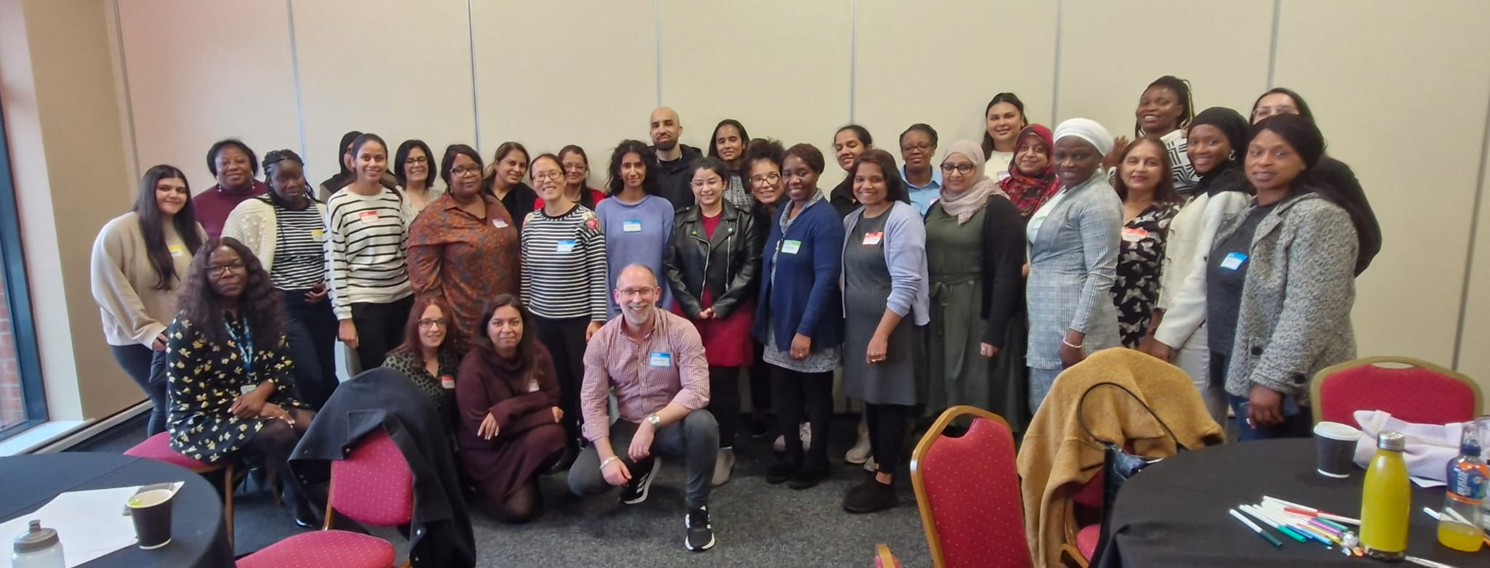

LLR is focussed on creating and sustaining an inclusive culture for people working in, and people accessing our health and care system and services.

Our ambition is to have a workforce which is representative of the diverse population across LLR. Supported and enabled by the development of diverse leaders it is evident that this provides diversity in action, thought. Thus, positively impacting the services/ care we deliver, patient safety and experiences.

Whilst we have many success stories, our Workforce Race Equality Standard (WRES) data shows that there are differences around progression for colleagues from Nursing, Advanced Allied Professionals (AHP) and Midwifery from BME backgrounds compared to other ethnic groups.

Data Inclusive of – University Hospitals of Leicester (UHL), Leicestershire Partnership Trust (LPT) and Integrated Care Board (ICB).

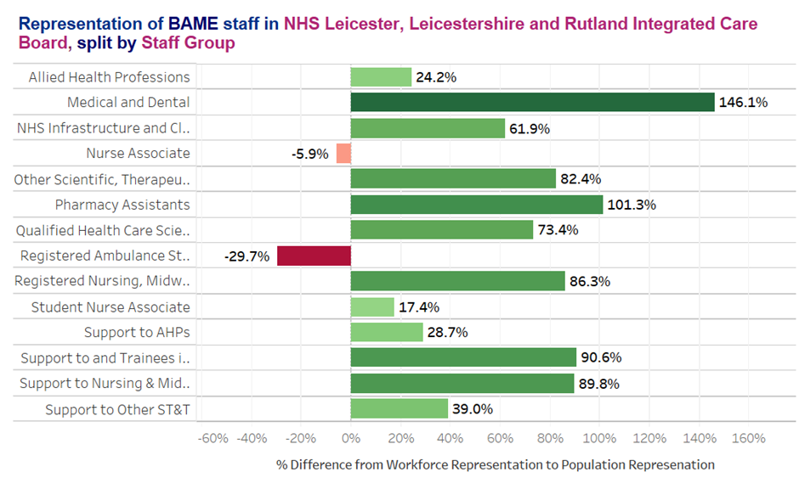
Data collected October 2025

To support this ambition, the ‘Developing Diverse Leaders (DDL)’ is tailor-made LLR pilot programme for aspiring Black, Asian and Minority Ethnic (BME) Leaders in the workplace. This was designed and launched in October 2022, and was specifically aimed at Midwifery, Nursing and Allied Health Professionals AHP (Bands, 5-7) and their line managers. This programme has also been discussed and supported by the LLR Nursing, Midwifery and AHP Expert Reference Group.

The programme aims to support and develop BME leaders of the future by:

- increasing diversity at a leadership level
- leading to better outcomes for colleagues and the communities we serve
- to offer the opportunity to access development and career progression to BME colleagues
- ensuring that colleagues have line management support which can play a pivotal role in making a difference to the experience that BME colleagues in the workplace
- enabling line managers to reflect on their experiences which may or may not impact their decisions in the workplace.

It is acknowledged that these initiatives also have a positive impact on BME workforce attraction, recruitment, and retention.

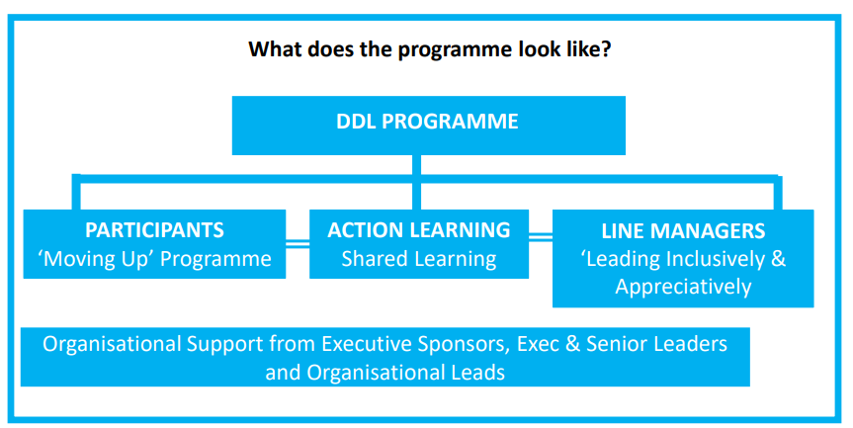

Our Community
We have successfully delivered the Developing Diverse Leaders programme to two cohorts of aspirant leaders and are actively delivering to our third cohort who will finish by March 2026.

Cohort One | Cohort Two | Cohort Three
- Blend of Bands 5, 6, 7 Nursing and AHPs.  - 29 Participants from UHL.  - 6 Participants from LPT.  - 2 Participants from ICB and LOROS.  - 36 Line Managers supporting their team members from across LLR. | - Blend of Band 5, 6, 7 Nursing, Midwives, AHPs and non-clinical staff.  - 16 participants from UHL  - 2 participants from County Council  - 1 participant from LLR ICB  - 5 participants from LPT  - 1 participant from LOROS  - 1 participant from Rutland Council  - 1 participant from City Council  - 26 sponsors support colleagues from across LLR | - Blend of Band 5, 6, 7 Nursing, Midwives, AHPs and non-clinical staff.  - 15 participants from UHL  - 1 participant from Rutland County Council  - 1 participant from LLR ICB  - 3 participants from County Council  - 4 participants from City Council  - 30 sponsors supporting colleagues from LLR and Northampton

Key
Advanced Allied Professionals (AHP)
University Hospitals of Leicester (UHL)
Leicestershire Partnership Trust (LPT)
Integrated Care Board (ICB)
LOROS Hospice Care

Key Themes from Cohort One of DDL:

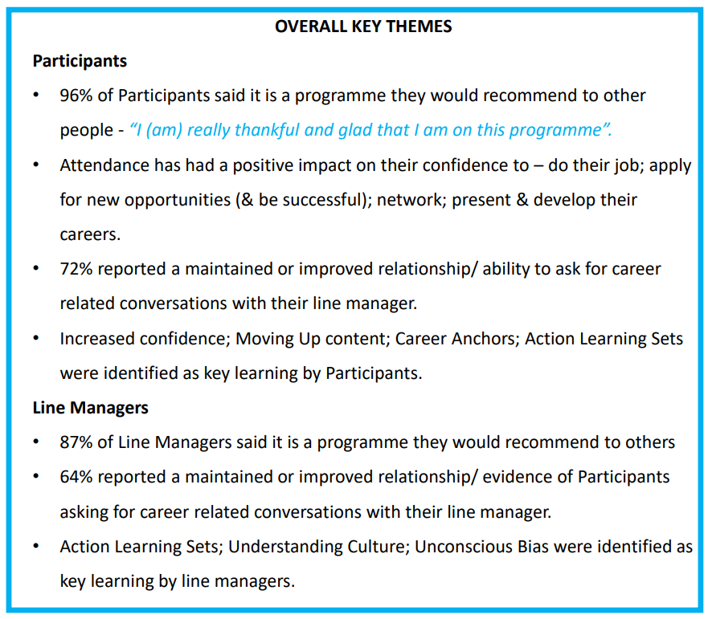

IMPACT – why do more?

From cohort one:
- 3 participants have been promoted whilst on the programme and have shared that it was directly attributable to this opportunity.
- 2 participants have achieved lateral career development whilst on the programme and have shared that it is directly attributable to this opportunity.
- Significant shift/ improved levels of confidence; presentation skills demonstrated at the celebration event.
- Creation of an inspiring group of people.

In the summer of 2025, we formed an alumni to keep our DDL cohorts connected and give them space to share their stories and grow together. The group chose to name their community the Leadership Lab, and they now meet regularly. The Leadership Lab Alumni Newsletters also promote ongoing personal development and shine a spotlight on outstanding members of our community.

LINK: developing diverse leadership programme – llr hwp)

We continue to track the journey and development of participants on these programmes with tailored career conversations to support their progression and overall development.

Current position:

Cohort three of this programme is currently being delivered. The programme content has been reviewed and revised in accordance with the feedback received from cohort one and two. Alongside the delivery of cohort two and three we are developing and are actively training a group of Train the Trainers to deliver this programme internally across the system.

- Leicester, Leicestershire and Rutland Nursing, Midwifery and Allied Health Professionals (AHP) Inclusive Leadership Group

The LLR Nursing, Midwifery and Allied Health Professionals (AHP) Inclusive Leadership Group brings together Nursing, Midwifery and AHP representatives from all levels of the ICS and will be responsible for developing and delivering system actions to address the historical inequity faced by minority ethnic Nursing, Midwifery and AHP staff in the NHS to have a representative and sustainable workforce.

The work is an integral part of the Equality and Diversity workstream led by the LLR People Board and is an important part of working together in more inclusive ways. In line with the LLR People’s Board EDI Strategy the top priorities are to:

- Embed Equality, Diversity and Inclusion into our culture and address bias in decision making.

- Promote inclusive and compassionate leadership so we can create a diverse workforce which is able to deliver 21st century care for all of the communities in LLR.

- Enable transformation and innovation across the LLR System

The group will focus on the 4 areas of delivering the priority actions identified:

System intelligence and data
    - Thematic analysis
    - Gaps in our data and mechanisms to capture relevant data.
Recruitment
    - Six high impact recruitment actions.
Engagement
    - Understanding our staffs lived experiences.
Personal development
    - Identify barriers to personal development.
    - Develop a strategic approach to removing barriers and developing opportunities for personal development.

The group will report into the Nursing, Midwifery and AHPs Cabinet (ICB) group. There is also an expectation that the Chair or ICB CNO reports into the NHSE Strategic Regional Nursing and Midwifery Delivery Group and the Operation Expert Reference Group.

As a result of the work of this group the ICB established the Developing Me: Developing You Talent Acceleration Programme.

- Developing Me; Developing You – Midlands Cultural Change Talent Acceleration Programme.

Cohort One of this Cultural Change Talent Acceleration Programme was commissioned and funded by NHSE Midlands. Led by the ICB it draws BME Nurses, Midwives and AHPs from across the LLR system focusing on band 8a and 8b and Allies at band 8c+.

The rationale for using this set of criteria for applications was based on analysis of what was available for this cohort of staff locally within each organisation in LLR ICB; what the ICB offered and what could be accessed across the region and national programmes.

Further analysis identified that there was little, or no development opportunities specifically designed for BME Nurses, Midwives or AHPs above band 7 locally.

The programme consisted of BME staff being matched with the Allies to form match pairs. within cohort one 14 matched pairs were created from across UHL, LPT, DHU and the ICB. Cohort one launched in October 2023 and ended in March 2024.

This programme offered:

- Master Classes held to support candidates with applications.
- For both BME Staff, and Allies.
- If there was difficulty in gaining line management support this was negotiated on their behalf.
- Independent psychologically safe space for both BME staff and Allies.

Initial feedback:

- Attendance was 100% at the time of writing.
- Engagement, that is, feedback received was also high at 95%.

Moving forward, the success of this programme has been reviewed and realigned to sit alongside the DDL programme, and it has now been rebranded as the Developing Diverse Senior Leadership Programme, which is currently being delivered to 20 Mentees and their Mentors from across Leicester, Leicestershire, Rutland and Northamptonshire.

- Developing Diverse Senior Leaders Programme

This programme aims to address the gap in senior leadership representation by providing a tailored development opportunity for Nurses, Midwives, Allied Health Professionals (AHPs), and non-clinical colleagues from minority ethnic backgrounds at Band 8a/b/c or Local Authority equivalent. By focusing on developing diverse senior leadership talent, the programme offers:

- A comprehensive training curriculum
- Stretch assignments that provide exposure to system projects, learning, development, and growth, while also improving services
- Coaching and dedicated sponsor support

Together, these elements are designed to:
- Promote inclusive leadership at sub-board level
- Enhance opportunities for networking
- Support further talent management and succession planning
- Create a foundation for learning and development with strategic links to the overall people priorities of the ICS

As the programme draws to a close, we are pleased to report excellent attendance, engagement, and feedback.

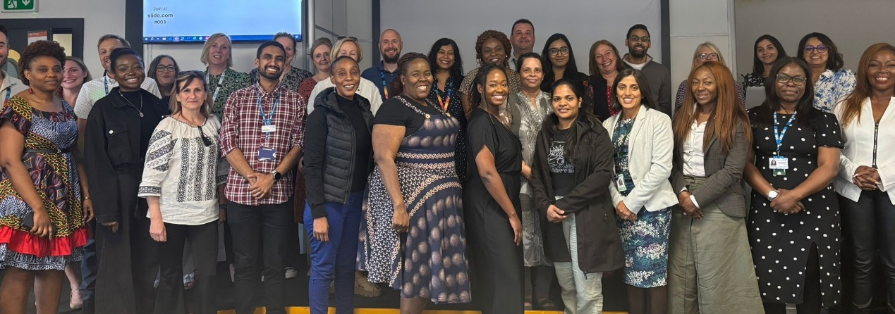

The Looking After Our People workstream
This is represented by health and wellbeing leads/champions from across health (including primary care), social care, emergency services and charities. The work of the group is integral to delivering against the Long-Term Workforce Plan / Association of Directors of Adult Social Services in England (ADASS) Time to Act priorities centred around workforce retention and wellbeing. A few initiatives undertaken by this group are noted below. This is aligned to the NHSE Health & Wellbeing Framework

LLR Buddying Framework

The LLR Buddying Framework has become a significant achievement across Leicester, Leicestershire, and Rutland, strengthening how teams welcome, support, and integrate new starters. Developed to enhance the induction experience, the framework provides clear guidance, structure, and resources that empower teams to create a warm, consistent, and supportive introduction to the workplace. Early adopters across the system have demonstrated how Buddying not only improves the confidence and experience of new colleagues, but also enriches team culture by recognising and elevating the everyday kindness, leadership, and compassion shown by LLR Buddies.
Across the pilot phase, the framework received overwhelmingly positive feedback from Buddies, Managers, and new starters alike. Teams reported smoother inductions, stronger peer relationships, improved role clarity, and an increased sense of belonging for new colleagues joining the system. Many Buddies also described personal growth in confidence, communication, and leadership skills. The success of the pilot has laid strong foundations for wider implementation, demonstrating the framework’s value in supporting workforce wellbeing, strengthening team cohesion, and celebrating the contribution of supportive colleagues who help make LLR a great place to work.
LINK: Visit the website for more information

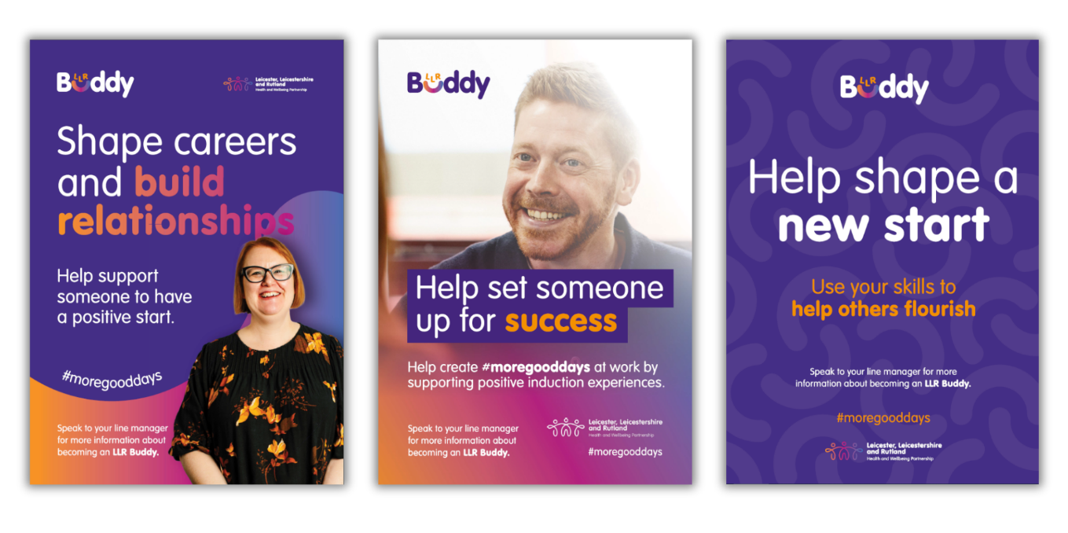

Commissioning and Provider Selection

ICBs commission services for their local community from a range of service providers that meet NHS standards and costs – these could be NHS hospitals, social enterprises, voluntary organisations, or private sector providers. This means better care for patients, designed with knowledge of local services and commissioned in response to their needs.

As an ICB we commission a wide range of services including primary care, mental health services, urgent and emergency care, elective hospital services and community care.

Equality, Diversity and Inclusion (EDI) continues to play a significant role in provider selection decisions taken under the Health Care Services (Provider Selection Regime) Regulations 2023. Improving access and reducing health inequalities are key criteria in all selection processes, and EDI requirements are embedded in all competitive procurement processes. The initial process requires all services to undertake an Equality Impact Assessment (EIA).
During 2025–26, the Primary Care Contracting team ensured that equality, diversity and inclusion considerations were embedded across all relevant service change processes. Key actions included:
- Equality Impact Assessments (EIAs) were completed for significant service change proposals, including the closure of a branch surgery, enabling the ICB to understand potential impacts on protected groups and mitigate risks.
- Practice merger applications were supported by EIAs, ensuring that the implications for access, continuity of care and vulnerable groups were assessed before decisions progressed.
- Patient and stakeholder engagement was consistently required for all service change proposals, with practices supported to undertake meaningful consultation in line with the ICB’s statutory duties.
- Healthwatch involvement was ensured in all consultation processes, strengthening independent patient voice and representation, particularly for seldom-heard groups.
- GP Practice relocation applications are subject to EIA requirements and patient/public consultation expectations. One relocation application received during the year remains in progress, with equality considerations monitored throughout.
This approach demonstrates ongoing commitment to meeting the Public Sector Equality Duty by embedding equality analysis, supporting inclusive engagement, and ensuring that potential impacts on diverse patient groups are fully considered in primary care commissioning/contracting decisions.

Health Inequalities

Health inequalities are avoidable and unfair differences in health between different groups of people. Health inequalities concern not only people’s health but the differences in care they receive and the opportunities they have to lead healthy lives.
Those living in the most deprived areas often have poorer health, as do some ethnically diverse groups and vulnerable/socially excluded groups. These inequalities are due to many factors, such as income, education and the general conditions in which many people are living. In addition, the most disadvantaged groups are not only more likely to get ill, but less likely to access services when they are ill.
Health Inequalities have been made worse by the Coronavirus pandemic, which has hit hardest the groups who already did not have the best health. The rate of people dying from the virus has been higher in more economically deprived areas and among some ethnically diverse communities and amongst disabled people. People in crowded housing, on low wages, unstable or frontline work have also experienced a greater impact from Covid 19.
The NHS contributes to tackling inequalities in health in three distinct ways:
- Influencing multi-agency action to address social determinants of health - The role of integrated care systems (ICSs) working with local authorities and local communities is particularly critical here.

- The NHS is a significant economic actor in its own right -
The choices we make as an employer, a purchaser and a local ‘anchor institution’ can help moderate inequalities.

- Tackling inequalities in healthcare provision - This is our direct responsibility and must be the prime focus of our action. The enduring mission of the NHS is high quality care for all. That means tackling the relative disparities in access to services, patient experience and healthcare outcomes.

Addressing health equity and health inequalities is central to all major strategies and work programmes for the ICB. The ICBs programme of work to improve health equity is guided by the principles set out in LLR Health Inequalities Strategic Framework - Better Care for All and embedded in the systems Integrated Care Strategy and Five Year Forward Plan. These strategic documents have been developed to ensure our residents have exceptional quality healthcare by ensuring equitable access, excellent experience and optimal outcomes. The ICBs strategic direction is built on the NHS inequalities improvement programme, the “CORE20Plus”.
LINK: LLR Health Inequalities Strategic Framework - Better Care For All Integrated Care Strategy

The LLR Health Inequalities Framework
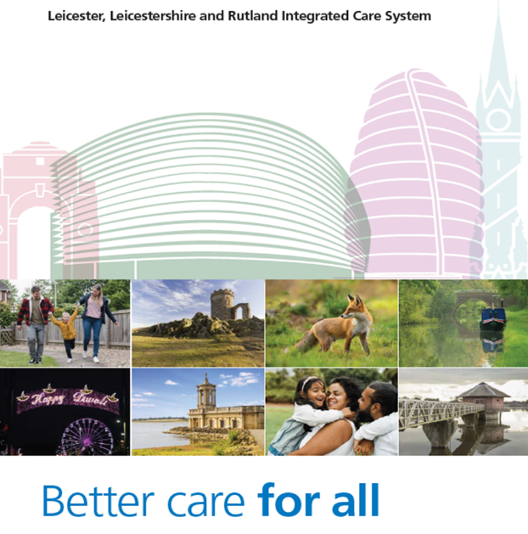
The LLR Health Inequalities Framework is the result of a collaboration of partners from across LLR, including the local NHS, Public Health, Health Watches and Local Authorities. It sets out our commitment to reducing health inequalities as a core purpose for the ICB, and for the future partnership which the Integrated Care System (ICS) represents.
The document sets out the principles we will work to, and the key actions we will take at system level to improve access to, experience of, and outcomes from local NHS services. This framework has been very positively received at regional and national levels.

Core20PLUS5 Framework
The NHS focus on reducing healthcare inequalities is stronger each year. The LLR ICB will be working on this agenda using the CORE20Plus5 framework. The framework asks the NHS to have developed specific plans for how it will improve access, experience and outcomes for:
- people in the least affluent 20% of the population (Core 20)
- for locally identified additional vulnerable populations regardless of deprivation, such as those who are homeless and those with a learning disability etc. (Plus)
- any of the following five key clinical areas of healthcare – cancer, severe mental illness, high blood pressure, pregnancy and birth, lung problems (5)

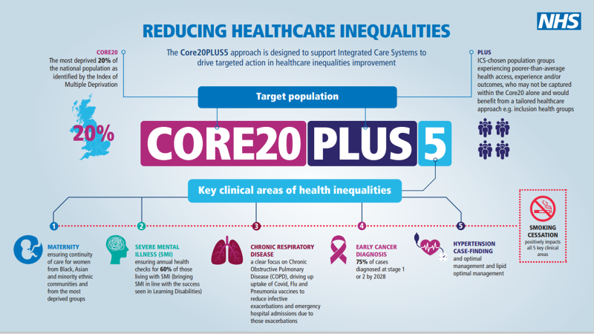

LLR ethnicity and deprivation – IMD 2025
 | 1 | 2 | 3 | 4 | 5
Asian/Asian British | 27.3% | 28.6% | 19.0% | 12.0% | 12.2%
Black/Black British | 5.8% | 5.0% | 2.7% | 1.8% | 1.6%
Chinese | 0.8% | 1.8% | 1.0% | 0.7% | 1.0%
Mixed | 2.8% | 3.6% | 2.2% | 2.2% | 1.9%
Not recorded | 5.0% | 5.9% | 5.1% | 4.3% | 4.4%
Other | 3.0% | 3.6% | 2.1% | 1.7% | 1.4%
White | 55.3% | 51.6% | 67.8% | 77.3% | 77.5%

Source: NHS MPI data November 2025 (ethnicity)
ONS IMD table 2025 (deprivation)

The table above looks at the breakdown of the LLR population by ethnicity and deprivation. People whose ethnicity is Asian/Asian British and Black/Black British have a significant percentage of the population living in the most deprived areas of LLR.
In November 2022, the Core20Plus5 framework was expanded to include children and young people in five different key clinical areas – Asthma, Diabetes, Epilepsy, Oral Health and Mental Health:
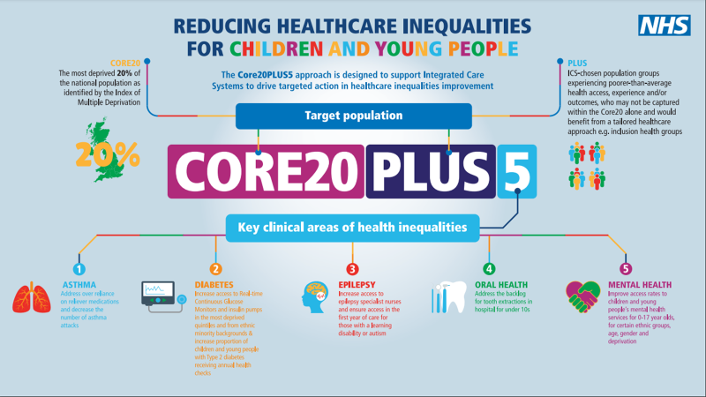
These frameworks emphasise that the detailed plans to reduce health inequalities in each of the three “places” in Leicester City, Leicestershire, and Rutland – will be led by the local Health and Wellbeing Boards, based on their knowledge of their population’s needs. These plans will be published in each area as a refresh of their Health and Wellbeing Strategies.

Five National Key Priorities for Systems and Providers
There are also five national key priorities for systems and providers that we will focus on in LLR and they are as follows:
Priority 1: Restoring NHS services inclusively
NHS performance reports should be broken down by patient ethnicity and Index of Multiple Deprivation (IMD) quintile, focusing on:
- Under-utilisation of services (e.g., proportions of cancelled appointments)
- Waiting lists
- Immunisation and screening
- Late cancer presentations
Priority 2: Mitigating against 'digital exclusion’
- Ensure providers offer face-to-face care to patients who cannot use remote services.
- Ensure more complete data collection, to identify who is accessing face-to-face, telephone and/or video consultations (broken down by patient age, ethnicity, IMD quintile, disability status or condition)
Priority 3: Ensuring datasets are complete and timely
- Improve collection of data on ethnicity, across primary care, outpatients, A&E, mental health, community services and specialised commissioning.
Priority 4: Accelerating preventative programmes
- Flu and Covid vaccinations.
- Annual health checks for people with severe mental illness (SMI) and learning disabilities
- Continuity of maternity carers
- Targeting long-term condition diagnosis and management
Priority 5: Strengthening leadership and accountability
- System and provider health inequalities leads to access Health Equity Partnership Programme training, as well as the wider support offer, including utilising a new Health Inequalities Leadership Framework (to be developed).

Fair Allocation of Resources for GP Practices

The model, created by one of our ICB primary care doctors was developed during 2020-21 using local population health data. The new model aims to ensure that practices have a fair allocation of an additional available primary care health equity funding pot based on the needs of our resident population. Practices in areas where health outcomes are poor will need greater resources to help bring these outcomes up to the level of the healthiest places in LLR. This model will help achieve that over time. This year we have undertaken a review of the model itself and of its impact to date. There are encouraging early data to indicate that the additional funding is having a positive effect on primary care provision where population needs are greatest. LLR was the first system in the country to do this and our work has received some very positive interest from NHS England as a possible model for primary care funding allocation.

LLR’s Statement on Information on Health Inequalities
Our initial report sets out the progress and the work that is taking place across Leicester, Leicestershire and Rutland Integrated Care Board (LLR ICB) to understand and target health inequalities. It reviews the challenges and progress through evidence and actions to provide assurance that the ICB is working with system partners to effectively identify and address inequity in both access to services and health outcomes. The report sets out LLRs statement on health inequalities which provides data and evidence of the scale of health inequalities experienced by the people of LLR.

The report presents data on health inequalities as set out in NHS England’s Statement on Information on Health Inequalities (duty under section 13SA of the National Health Service Act 2006) (3)

The data includes the ten domains set out in NHS England’s statement and - where available - focuses on variables by deprivation and ethnicity. The indicators align to the five priority areas for addressing healthcare inequalities set out in the priorities and operational planning guidance and the Core20PLUS5 approach. The domains included are:

- Elective recovery
- Urgent and emergency care
- Cancer
- Cardiovascular disease
- Respiratory disease
- Diabetes
- Mental health
- People with learning disability and autism
- Maternity and neonatal
- Oral health

The report provides high-level descriptive analysis only and is intended to help monitor activity - leading to more detailed and robust analysis where appropriate to drive improvement projects to further reduce healthcare inequalities.

LLR’s Statement on Information on Health Inequalities will be refreshed during 2026 and will be published on our website. The revised statement has 5 areas for focus in the annual report:
- Understanding health needs
- Understanding healthcare access, experience and outcomes
- Improving data quality, collection and analysis
- Using information on healthcare inequalities
- Publishing information.

NHSE supply a number of Key Lines of Enquiry (KLOEs) to support narrative needed in annual reports around how ICBs are addressing inequalities, how they are using data to inform change and decision making, what improvements are being made to data quality and how is the data being used to monitor inequalities throughout the year.

A measurement framework has been developed, as shown below. Measures provided in the framework are not prescriptive but there to help local areas identify which are the most important for their reports.

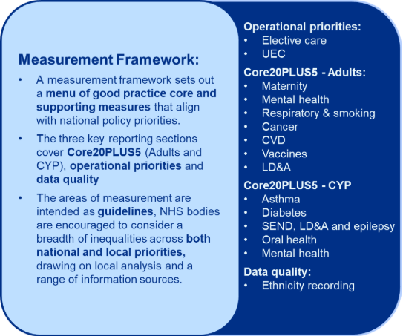

NHSE – Annual Assessment of ICB Performance 2024/25. Published 17 December 2025

NHSE wrote “There has been clear evidence supplied that health inequalities are embedded within system leadership with defined strategies and routine reporting against deliverables​.

The LLR ICB is a recognised leader in many areas of this work with notable achievements in sophisticated data stratification on cancer screening uptake and a strategic long-term approach to primary care financing to level-up funding based on population need​”.

Engagement and Insights

Specialist Engagement and Consultation with Communities
We are committed to eliminating discrimination based on age, disability, gender, pregnancy and maternity, race, religion and belief, sex, sexual orientation or socio-economic disadvantage.
Prior to commencing any engagement project, we seek to understand the socio-demographics of the geographic area we are seeking to hear the voices of, if it is not a health system wide project. An Equality Impact Assessment along with a review of population health management data also helps us to understand at the start of any project the people and communities we need to engage to ensure proportionate representation from the population, particularly focusing on those from the protected characteristics.
To get the required assurance and clarity, in all engagement/consultation activities we ask equality questions across socio-demographics and protected characteristics. This information is optional to complete, but at the end of the research, this information gives us clarity on whether we have involved people who are statistically and demographically representative and helps to assure whether the insights are in tune with the attitudes of the entire population and meets the pre-determined quota.
Together with the insights gathered, this information is used to make commissioning decisions and influence how and what services are provided. This helps to ensure that accessible care and treatment is delivered in a way that respects the needs of each individual and does not exclude anyone.
We recognise that the ICB is not always best placed to gather insights and intelligence from all communities. For some time now we have worked in partnership with the voluntary and community sector through the ICB Voluntary, Community and Social Enterprise (VCSE) Alliance. Through an Opportunities Hub on our website, we commission this sector to work within their communities to gain experiences from individuals and communities to understand what matters to them on a range of services. These insights are then fed into the overall Report of Findings for each project.
For example, in the summer of 2025 the ICB commissioned a wide range of VCSE organisations to work with us to engage with communities across Leicester, Leicestershire and Rutland on how to get NHS fast then they need it. This comprised of an extensive education programme, which particularly focused on those who lived in the city. Each organisation tailored the methods they would use to engage with their audiences to maximise involvement.
The programme wished to target individuals living in LE1, LE2, LE3, LE4 & LE5 postcodes and surrounding areas, specifically those who live within the 1-mile radius of Leicester Royal Infirmary and those communities living in the Leicester City boundary on the main arterial roads into Leicester City.

Applicants targeting the following groups were prioritised, with 20 awarded funding:
- New and young families, especially those with babies and young children under the age of 10
- People within the age group of 21-30 years (young professionals) and 31-40 years
- Individuals experiencing homelessness
- Refugees and asylum seekers
- Eastern European and Black, Asian, and Minority Ethnic communities
- Groups with barriers to healthcare access, including those with protected characteristics.
In addition, the team attended a wide range of events reaching across Leicester, Leicestershire and Rutland. This included supermarket stalls, warden training at Loughborough University, libraries and two school assemblies.
The findings from this engagement and detail of activity are not finalised at the time of writing this document but will be available on our website from Spring 2026.
In 2025-2026 we formally reported on the outcome of engagement and consultation in two key areas.
Our Report of Findings for both projects are published on the ICB website.
Highlighted below are some of the key outcomes:
East Midlands Fertility Policy Listening Exercise
Between 11 November 2024 and 10 January 2025, NHS Integrated Care Boards across the East Midlands (covering Derbyshire, Leicestershire, Lincolnshire, Northamptonshire, Nottinghamshire, Rutland, Derby, Leicester, and Nottingham) asked people across the region for their views on a new, unified fertility policy. This policy aims to ensure everyone has fair and equal access to IVF and other fertility treatments, regardless of where they live or their background.
A total of 264 respondents to the questionnaire stated that they lived in Leicester, Leicestershire, or Rutland. Outlined below is a breakdown of the equality data for these respondents.

More details on the listening exercise, including the full report of findings, can be found at: LINK: https://derbyshireinvolvement.co.uk/fertilityreview.

Protected characteristic | Response rate
Age | 256 people answered this question.  - 0.39% of respondents were under 18.  - 1.95% were aged 18–24.  - 33.98% were aged 25–34.  - 29.30% were aged 35–44.  - 11.72% were aged 45–54.  - 12.11% were aged 55–64.  - 4.69% were aged 65–74.  - 2.34% were aged 75–79.  - 1.56% were aged 80 or over.  - 1.95% preferred not to say.
Sex | 255 people answered this question.  - 11.76% of respondents identified as male and 85.10% as female.
Gender reassignment (process or intention) | 253 people answered this question.  - 2.77% of respondents said they had gone through, or intended to go through, part of a process to change from the sex assigned at birth to the gender they identify with.  - 94.47% said they had not.  - 2.77% preferred not to say.
Sexual orientation | 254 people answered this question.  - 84.25% of respondents identified as heterosexual or straight.  - 7.09% identified as gay women or lesbians.  - 0% identified as gay men.  - 2.76% identified as bisexual.  - 1.18% identified as pansexual.  - 0.39% identified as asexual.  - 3.94% preferred not to say.  - 0.39% chose to self-describe their sexual orientation.
Disability or ill health | 241 people answered this question.  - 0.41% reported a vision-related condition.  - 3.32% reported a hearing-related condition.  - 8.71% reported mobility difficulties.  - 2.07% reported dexterity-related issues.  - 0.83% reported difficulties with comprehension or concentration.  - 0.83% reported memory issues.  - 5.39% reported mental ill-health.  - 2.49% reported stamina, breathing, or fatigue-related difficulties.  - 2.90% identified as neurodivergent.  - 75.10% reported no health conditions.  - 5.81% preferred not to say.  - 5.39% provided another comment or definition of their condition or illness.
Carers | 245 people answered this question.  - 11.43% of respondents provided care for someone with long-term physical or mental ill-health or a disability.  - 14.69% provided care for someone experiencing problems related to old age.  - 73.06% said they did not have caring responsibilities.  - 4.49% preferred not to say.  - 1.63% selected ‘other’.
Ethnicity or background | 254 people answered this question.  - 77.56% identified as White – English/Welsh/Scottish/Northern Irish/British.  - 2.36% identified as White – Other.  - 0.39% identified as Mixed – White and Black Caribbean.  - 0.79% identified as Mixed – White and Black African.  - 1.18% identified as Mixed – Other.  - 10.24% identified as Asian/Asian British – Indian.  - 0.79% identified as Asian/Asian British – Pakistani.  - 1.18% identified as Black – African.  - 0.39% identified as Chinese.  - 4.72% preferred not to say.  - 0.39% selected ‘any other ethnic group’.  - All other listed categories received 0%.
Religion or belief | 253 people answered this question.  - 47.83% of respondents reported having no religion.  - 32.81% identified as Christian.  - 0.40% identified as Buddhist.  - 7.11% identified as Hindu.  - 1.58% identified as Muslim.  - 1.19% identified as Sikh.  - 7.11% preferred not to say.  - 1.98% selected ‘any other religion’.  - 0% identified as Jewish, Baha’i, or Jain.

Proposals to improve access to same day health services in Rutland
Between January and March 2025, we consulted on proposals to improve services for people in and around Rutland by bringing together two existing services – the Minor Injuries Unit and the Urgent Care Centre – to create a Minor Illness Service which would be open seven days a week at Rutland Memorial Hospital.
The consultation was designed to be inclusive and accessible, using both online and offline methods to reach people across Rutland’s diverse and rural communities. Multiple formats were provided, including printed surveys, Easy Read materials, translation support, and a video, to meet different communication and accessibility needs.
Targeted outreach was carried out to engage seldom heard groups and people with protected characteristics. Demographic monitoring throughout the consultation helped identify underrepresented groups and guide additional engagement. VCSE partners played a crucial role in reaching disabled people, older adults, veterans, people with mental health needs, LGBTQ+ communities, and families.
A strong local presence ensured rural and digitally excluded residents were not left behind, with visits to most villages and distribution of materials through community venues. Children and young people were engaged through schools, youth groups, and sports clubs.
Partnership working with councils, NHS organisations, community groups, and local networks ensured information reached a wide range of communities, supporting a fair and representative consultation process.
A total of 1,334 usable responses to the consultation questionnaire were included in the analysis. The composition of these responses by method of participation was:
- 1,195 online responses
- 136 postal/hard-copy responses
- 3 Easy Read responses

In addition to the questionnaire responses, further formal feedback was submitted through other channels, including:
- Direct emails from 13 individuals
- Written submissions from Healthwatch Rutland and the Health & Social Care Policy Consortium

Outlined below is a breakdown of the equality data for these respondents.

More details on the consultation, including the full report of findings, can be found at:
LINK: https://leicesterleicestershireandrutland.icb.nhs.uk/be-involved/rutland-same-day-access-consultation/

Protected characteristic | Response rate
Age | - 1% of respondents were aged 16–19.  - Fewer than 0.5% were aged 20–24.  - 3% were aged 25–34.  - 16% were aged 35–49.  - 27% were aged 50–64.  - 25% were aged 65–74.  - 20% were aged 75–84.  - 3% were aged 85 or over.  - 2% preferred not to say.
Sex | - 25% of respondents identified as male.  - 68% identified as female.  - 2% preferred not to say.  - 4% did not provide information.
Gender identity | - 93% of respondents said they identify as the gender assigned to them at birth.  - Fewer than 0.5% said they do not identify as the gender assigned at birth.  - 3% preferred not to say.
Sexual orientation | - 83% of respondents identified as heterosexual or straight.  - 2% identified as bisexual.  - 1% identified as gay or lesbian.  - 1% selected another orientation.  - 10% preferred not to say.  - 3% did not provide information.
Disability or ill health | - 13% of respondents said they had a disability.  - 9% reported being in poor health.  - 11% reported a long‑standing illness or condition.  - 10% reported a physical impairment.  - 4% reported partial or total loss of hearing.  - 3% reported a mental health condition.  - 1% reported partial or total loss of vision.  - 1% reported a learning disability or difficulty.  - Fewer than 1% reported a speech impairment.  - 3% reported another medical condition.  - 1% preferred not to say.  - 72% said they did not have a disability.
Carers | - 11% of respondents provided care for a young person aged 24 or younger.  - 2% cared for adults aged 25–49.  - 13% cared for someone aged 50 or over.  - 71% said they did not provide care for anyone.  - 3% preferred not to say
Ethnicity or background | - 93% of respondents identified as White.  - 1% identified as Asian or Asian British.  - Fewer than 0.5% identified as Black or Black British.  - Fewer than 0.5% identified as Mixed.  - Fewer than 0.5% identified as ‘other’.  - 3% preferred not to say.  - 3% did not provide information.
Religion or belief | - 58% of respondents identified as Christian.  - 31% said they had no religion.  - Fewer than 0.5% identified as Hindu, Buddhist, Muslim, Jain, or Jewish respectively.  - 1% selected another religion or belief.  - 6% preferred not to say.  - 2% did not provide information.
Pregnancy and maternity | - 1% of respondents said they were pregnant or had given birth in the last 26 weeks.  - 1% preferred not to say.  - 7% did not provide information.
Armed Forces community | - 7% of respondents had previously served in the Armed Forces.  - 3% were family members of someone serving.  - 2% were civilians working in the Armed Forces.  - Fewer than 0.5% were serving personnel.  - 82% said none of these applied to them.
Farming community | - 3% of respondents said they were members of the farming community.  - 96% said they were not.  - 1% preferred not to say.  - Fewer than 0.5% did not provide information.

Across protected characteristics, agreement patterns with the consultation proposals were broadly consistent. Where differences were observed, older respondents showed higher agreement with creating a combined Minor Illness Service, while carers and members of the farming community showed slightly lower agreement than non‑carers and non‑farming respondents. Younger respondents, single respondents, and those who were pregnant or had recently given birth were more likely to agree with proposals relating to appointment booking through GP practices or NHS 111, and with proposals for providing X‑ray services on specific days. These observations should be interpreted cautiously, as some groups had small numbers of respondents.

LLR ICB People and Communities Strategy (2022-2024)

The ICB has continued to deliver the LLR ICB People and Communities Strategy (2022 – 2024) and is working to deliver a refreshed version whilst it transitions into its strategic commissioner role. The Strategy identifies seventeen priorities which collectively help to ensure that the voice of people and communities is embedded at all levels of the ICB.
The priorities are subdivided into key areas:
- Insights, experiences and business intelligence – ensuring that there is useful and relevant evidence of the voices of patients, carers, staff and stakeholders impacting on decision making, service design and delivery and it is representative of the socio-demographics of our population.
- Governance – ensuring that the patient voice influences at all levels of the ICB.
- Relationships Management – working collectively across the ICB to build relationships that influence services and improve the lives of the people we service.
- Infrastructure development and implementation – ensuring that all new infrastructure, whether at system, place or neighbourhood has inbuilt in processes to ensure that people and communities co-design and co-produce healthcare.
- Reducing health inequalities – ensuring that all projects and programmes of work align to our Public Sector Equality Duty and show evidence of adherence.
- Delivering our legal and statutory duties to involve and reduce inequalities – ensuring that service design and delivery is influenced by the patient/service user voice and experiences and ‘Report of Findings’ demonstrate satisfaction levels and ability to access services and are disaggregated by protected characteristics and published.
In April 2026 work will begin with partners to develop the next 3-year People and Community Strategy for Leicestershire, Northampton and Rutland.

Voluntary, Community and Social Enterprise (VCSE) Alliance

The LLR Voluntary, Community and Social Enterprise (VCSE) Alliance is a formal, strong and mutually beneficial partnership with the sector, created to tackle health inequalities, empower communities and embed their voices into the heart of the health and care system. Co-designed with the sector, the Alliance moves us beyond a system of merely contracting in support as and when needed, to a place where we work in close and equal partnership, working collaboratively to find solutions that tackle health inequalities.

The Alliance, which was launched in November 2022, was born out of, and builds on the relationships formed both during the pandemic and during the large scale Building Better Hospitals public consultation. However, it started to take shape during a second large scale public consultation – Step up to Great Mental Health.

The core focus of the work of the Alliance is on:
- Health prevention
- Population health management
- Reduction in health inequalities
- Receiving evidenced base insights and business intelligence
- Delivering high quality communications and involvement

The VCSE Alliance has:

- More than 300 subscribers to the online VCSE Alliance Forum representing communities with protected characteristics.
- 245 VCSE Alliance members who are signed up to the VCSE Directory and the Opportunities Hub representing communities with protected characteristics.
In addition, two events have been held. They include the VCSE Alliance Annual Conference held in July 2025 which brought together VCSE organisations and NHS leads to look at recent successes, the 10-year plan and the vaccination programme.

The VCSE Alliance forum activity has significantly increased with more events, information and topics shared by the ICB and individual organisations.

Insights, Behaviour and Research Hub
ICB partners utilise the Insights, Behaviour and Research Hub. The Hub, which contains insights and business intelligence, enables organisations to work more efficiently together ensuring that the voice of patients, family carers, staff and communities impact the way in which services are provided and support the redesign of services.
The objectives of the Insights, Behaviour and Research Hub are to:
- Provide information and aid in identifying gaps to help to promote understanding of what people need (including our most vulnerable groups) from local NHS services.
- Support the Integrated Care System (ICS) teams and delivery groups to interpret, utilise and identify gaps from the data in planning and decision-making processes.
- Provide the system Quality and Safety Committee with robust data that supports them to provide assurance to the ICB Board regarding the safety and quality of care to the population we serve.
- Enable patterns of poor quality to be identified and reported to the Quality and Safety Committee and other appropriate committees.
- Tackle health inequalities by helping to ensure that we are involving a true representation of our population.
- Encourage collaboration with delivery groups to identify the impact of intelligence and articulate clearly, the difference it has made.
- Promote collaboration between the ICB, Leicestershire Partnership Trust (LPT) and University of Hospitals Leicester (UHL) and Healthwatch Leicester and Leicestershire and Healthwatch Rutland. In the longer term it will also support joint working with local authorities and voluntary and community organisations.
- Provide and encourage data sharing securely across organisations which encourages financial savings by developing joint systems and processes that reduce duplication.
- Feedback to people and communities so that they can see how their voice has impacted services.
- Allow information provided by partners to be accessible in the hub.
- Ensure that the information is structured by place and communities that aligns with the ICB strategy.

Conclusion
The LLR ICB continues to demonstrate compliance to our legal and mandated equalities duties. We continue to embed equality considerations into decision making. This includes commissioning decisions that impact our communities and also internal workforce changes which directly or indirectly impact on our workforce. END

Appendix A


Forward Plan

The following Plan contains a number of high-level equality related actions and priorities we will be undertaking during 2026-2027 (Note that some of these actions may change as we cluster with Northampton ICB.)
Public Sector Equality Duty (PSED)
- As the transition towards LNR Cluster ICB progresses, collaborate with NHS Northamptonshire ICB to review the EIA process to produce one consistent approach.
- Encourage more Equality Monitoring to increase specific protected characteristics data to inform service and employment planning.

Commissioning and Provider Selection
- Continue to ensure relevant equalities considerations are contained in procurement and provider selection exercises.

- In considering health care services, relevant authorities must be aware that equalities duties in the Equality Act 2010, including the Public Sector Equality Duty, are relevant to all key selection criteria and due regard to these requirements must be given when considering each criterion. They may also be particularly relevant when considering the social value criterion, which is an explicit requirement of all public sector procurement regulations.

Workforce

EDI Improvement Plan
- As the transition towards LNR Cluster ICB progresses, collaborate with NHS Northamptonshire ICB to ensure consistency of approach and identify any areas for improvement.
Internal People Plan
- Once the Management of Change process is concluded, the ICB will support staff and work with NHS Northamptonshire ICB to develop an LNR Cluster ICB People Plan. There is already an LNR Cluster ICB OD Plan, which is important for creating the future LNR Cluster culture and new ways of working.
Engagement
- Develop the new People and Communities Strategy for Leicestershire, Northamptonshire and Rutland to ensure that people with protected characteristics are a golden thread throughout our work.
- Strengthen and build on the Insights, Behaviour and Research Hub, and develop its use to further enable insights to inform decision making.

Health Inequalities
- Addressing health equity and health inequalities is central to all major strategies and work programmes for the ICB. The ICBs programme of work to improve health equity is guided by the principles set out in LLR Health Inequalities Strategic Framework - Better Care For All and embedded in the systems Integrated Care Strategy and the Five-Year Plan (see links below). It should be noted that the ICB 5 Year Plan will be revised in 2026 to reflect the requirements in the NHS 10 Year Plan. These strategic documents have been developed to ensure our residents have exceptional quality healthcare by ensuring equitable access, excellent experience and optimal outcomes. The ICBs strategic direction is built on the NHS inequalities improvement programme, “CORE20Plus5”.
LLR Health Inequalities Strategic Framework - Better Care For All
Integrated Care Strategy
Five-Year Plan

Reducing healthcare inequalities – Core20Plus5 Adults and CYP
The focus remains on addressing the five priorities in the NHS Operational Planning Guidance:
- Priority 1: Restoring NHS services inclusively
- Priority 2: Mitigating against ‘digital exclusion’
- Priority 3: Ensuring datasets are complete and timely
- Priority 4: Accelerating preventative programmes
Priority 5: Strengthening leadership and accountability

Final
Alt text included/Accessibility checked 02/04/2026.
Cursor flow checked for tables 02/04/2026.

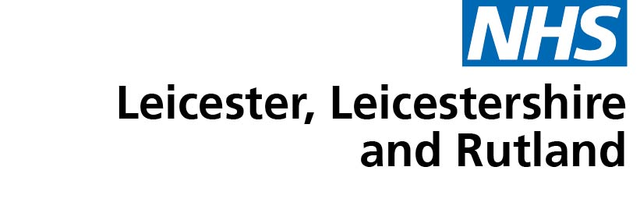

Room G30
Pen Lloyd Building
County Hall
Glenfield
Leicester
LE3 8TB

Tel: 0116 295 7572 / 0116 295 3405

www.leicesterleicestershireandrutland.icb.nhs.uk

The Armed Forces Covenant Duty of Due Regard
Statutory Guidance on the Armed Forces Covenant Duty November 2022
NHSE: Healthcare for the Armed Forces community: A forward view dated March 2021
https://www.england.nhs.uk/2021/03/nhs-celebrates-the-vital-role-hundreds-of-thousands-of-women-have-played-in-the-pandemic/

